BAS Ice Shelf Data Logger Manual
Version | Date | Revisions
1.0 | 09/08/2022 | New version for updated codebase designed to handle all instrument combinations
1.1 | 13/04/2023 | Added support for inductive SBE-37 CTD instruments
1.2 | 06/07/2023 | Added new and revised existing config file options
1.3 | 04/08/2023 | Added support for RBR Inductive Modem system
1.4 | 22/11/2013 | Added support for RBRcoda T.ODO and additional sensors attached to RBRconcerto CTDs
1.5 | 20/08/2024 | Added support for serial SBE-37 CTD instruments

Table of Contents
Overview 4
Requirements 5
Preparing the Data Logger 7
Set Real Time Clock 7
Programme New Software 8
Instrument Setup and Configuration 10
A note on sampling schedules 10
SBE 37-IM CTD (inductive modem) 11
SBE 37-SM CTD (serial) 14
RBRconcerto CTD 16
RBRcoda T.ODO 20
Nortek Aquadopp 22
Nortek Aquadopp Profiler 26
Impact Subsea ISA 500 29
Soundnine XT 31
Soundnine Inductive Modem Configuration 32
Batteries and Desiccant Packs 32
Ultimodem ID & Configuration 32
OEM Surface Ultimodem 35
RBRconcerto CTD 36
RBRcoda T.ODO 37
Nortek Aquadopp 38
Nortek Aquadopp Profiler 39
Impact Subsea ISA 500 40
RBR Inductive Modem Configuration 41
Head End Modem configuration 41
Sub Surface Modem configuration 43
Data Logger Configuration File 45
Required key-value pairs 45
Optional key-value pairs 46
Inductive modem 46
Soundnine XT 47
SBE 37-IM CTD (inductive modem) 47
SBE 37-SM CTD (serial) 47
RBRconcerto CTD 47
RBRcoda T.ODO 48
Nortek Aquadopp 48
Nortek Aquadopp Profiler 49
Nobska MAVS 49
Impact Subsea ISA 500 49
SBD Iridium Communications 51
Data messages 51
Configuration messages 53
SD Card Endurance 55
Real-Time Data During Mooring Deployment 56
Deploying the Data Logger 58
Power System and Antenna Setup 58
GPS and Iridium Communication Checks 59
GPS 60
Iridium 60
Switching on the Logger 61
Appendix 1 – Task Scheduler Codes 63

Overview
The BAS Ice Shelf data logger is designed to collect data from oceanographic instruments connected directly to the logger via one of the two serial ports or over an inductive link provided by a Seabird, Soundnine or RBR (future development) inductive modem. The data logger is based around a Microrobotics VM2 controller, which is connected to a “General Purpose (GP) Logger” circuit board developed by BAS and Microrobotics. This board provides the data logger with 2xSD card slots, GPS, Iridium modem, power zoning and serial communications. The system is mounted in a Pelican case and can be powered by a 12 V power system.
The logger firmware is designed to collect data from any combination of Soundnine XT sensors, Nortek Aquadopps and Aquadopp Profilers, Seabird SBE-37 Microcats, RBRconcerto CTDs, coda T.ODOs and thermistor cables, NOBSKA MAVS acoustic current meters, and Impact Subsea ISA 500 underwater altimeters. The number of different instrument types that are attached to a logger is specified in the configuration file that is held on the SD cards. The data logger can communication with these instruments over its serials ports using either a direct cable connection or an SBE, Soundnine or RBR inductive link.
In most instances the instruments attached to the data logger will be running autonomously on a predefined deployment schedule, and the data logger will poll the instruments at a specified interval to collect the latest samples. For instruments that cannot be programmed to run autonomously (e.g. Soundnine XT sensors or Impact Subsea ISA 500 underwater altimeters) the data logger will periodically wake and command these instruments directly to take a set of observations. The sampling interval parameters for each type of instrument are specified in the configuration file. The required parameters vary between instruments and must be checked carefully before deployment. The number of specified sampling interval parameters is crosschecked against the number of specified tasks when the data logger is switched on, and a warning is displayed if there is a mismatch. The parameters required for each instrument type are discussed in detail later in this manual.
During each sampling interval for each instrument type, a subset of observations is added to the Iridium Short Burst Data (SBD) buffer. The data logger carries out a set of housekeeping task on a specified schedule that is set in the configuration file, which includes completing the Iridium SBD uplink to transfer the housekeeping data and the subset of observations. The Iridium connection can also be used to reconfigure the data logger remotely. A queue system has been implemented for the SBD messages to ensure that no messages are lost if the SBD uplink periodically fails. The length of this queue can be specified in the configuration file. During each instrument sampling task, the Iridium SBD buffer is saved to the SD cards ensuring there is no data loss in the event of the data logger resetting.

Requirements
Before a data logger can be deployed, each instrument must be set up correctly, which can include specifying the sampling schedule, setting the command string required to interrogate the instrument, or configuring the inductive modem attached to the instrument’s underwater connector. The details of the setup required for each instrument type are set out later in the manual. The software packages that are required depend on which instruments are attached to the logger. A complete list is provided below.
Seabird (SBE)
SeatermV2 (v2.8.0.119) available here: https://www.seabird.com/software
RBR
Ruskin (v2.20.4) available here: https://rbr-global.com/products/software/
Nortek
Aquadopp deepwater (v2.00.02) available here: https://www.nortekgroup.com/software
Aquadopp Profiler (v2.00.02) available here: https://www.nortekgroup.com/software
Impact Subsea
seaView (v1.9.0) available here: https://www.impactsubsea.co.uk/seaview/
Terminal emulators
Tera Term (v4.106) available here: https://osdn.net/projects/ttssh2/releases/
Realterm (v2.0.0.70) available here: https://sourceforge.net/projects/realterm/files/Realterm/2.0.0.70/
Text editors
Notepad++ (v8.5.6) available here: https://notepad-plus-plus.org/downloads/
HxD hex editor (v2.5.0.0) available here: https://mh-nexus.de/en/downloads.php?product=HxD20
The hardware required to deploy a data logger includes:
- A serial cable and PC with a serial port (D type 9 pin), or a USB port and a serial-USB converter
- Data logger power cable
- 12V power supply
- Solar panel and connector cables/regulators
- 1 or 2 SD-cards (minimum of 1) + card reader
- Antenna and solar panel mast (eg, 4-m glacio-pole)
- Iridium + GPS antenna bracket
- GPS + Iridium antenna and cable
- Hose clips or equivalent to attach the antenna bracket to the pole
- Cable ties to tidy up the GPS and Iridium cables
- A small sheet of plywood to cover the data logger pit before re-filling the hole with snow
- Marking flags
A note about SD cards: The data logger has been tested with cards up to 32GB. There have been problems in the past with Transcend 16GB cards, and therefore it is recommended to avoid them. SanDisk Extreme Pro seem to work well but are rated only to -25°C. This will be fine for most summer use and the have been used successfully down to -40°C. Panasonic make a -40°C, 16GB card, which is relatively slow, but good value. High speed cards are not required for this application. The cards must be formatted as FAT32.
TTL cable driver: the TTL cable that allows the data logger to communicate with a PC requires a driver to be installed on the host PC operating system. The 64-bit driver for Windows (Desktop) is required and can be downloaded here: https://ftdichip.com/drivers/vcp-drivers/ (latest version 2.12.36.4).

Preparing the Data Logger

Set Real Time Clock
Before the logger can be deployed, the real time clock on the VM2 needs updating to the current time and date in UTC. The VM2 clock can exhibit considerable drift over time (30 minutes per year), so this correction is best done close to deployment. During the deployment itself, the VM2 will be updated daily with the GPS time, ensuring any drift is kept to a minimum.
To update the real time clock, attach the Terminal (TTL) cable to the data logger mainboard (orientate the connector such that the missing wire aligns with the VCC pin) and plug into a PC via USB. Move the Prog (2) DIP switch to On. Open the Venom IDE and select Terminal from the top menu bar, followed by Terminal Settings…. Set the correct COM port and click OK (leave all other settings unchanged). If a box in the bottom left of the IDE shows Closed, select Terminal from the top menu bar, followed by Open/Close COM Port.
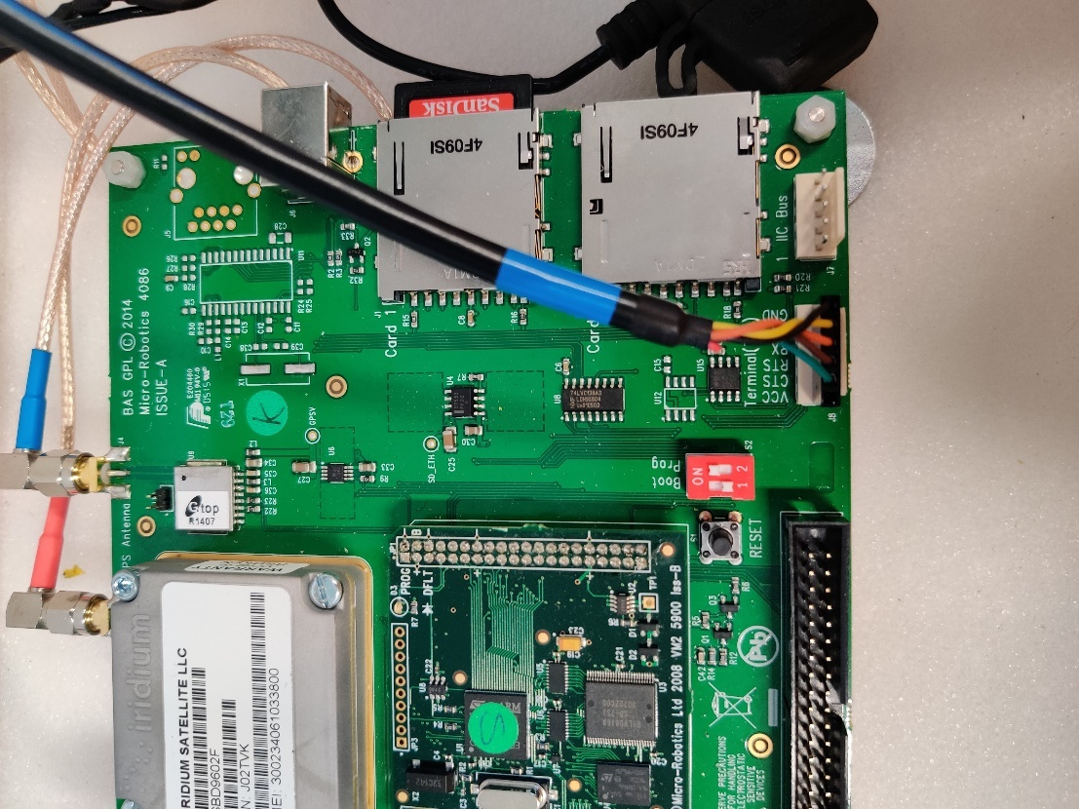
Apply 12 V power to the logger using a battery or DC power supply and turn it on using the power switch on the side. In the Venom IDE, the terminal should respond with:
VM2 Control Computer running Venom2 at 72MHz
### PRE-RELEASE
Version 2023 05 24
Copyright 2023 Venom Control Systems Ltd.

Application in Flash: Erase Application?
Press N to confirm that we don’t wish to delete the programme currently stored in the logger’s flash memory. To change the real time clock, copy the following command into the terminal, and update to reflect the current time and date in UTC:
Print to Clock, “2022-10-10 09:36:00”
Press enter to store the new date and time. To confirm that the new time has been set, you can print the current VM2 date and time using the print Clock command. Once the time and date has been correctly set, power off the logger and return the Prog (2) dipswitch to the Off position.
Alternatively, if a GPS antenna is attached to the logger, the real time clock can be automatically synced to GPS. Follow the instructions above to connect to the logger, change the position of the Prog (2) dipswitch, apply power, and confirm that we don’t wish to delete the programme currently stored in the logger’s flash memory. To sync the real time clock, initialise the logger using the init command (an SD card must be present) and then run mainboard.sync_clock_to_gps(). Wait for the process to complete and then confirm the real time clock has been set using the print Clock command. Power off the logger and return the Prog (2) dipswitch to the Off position.

Programme New Software
In rare instances, the data logger may need to be reprogrammed with new software in the field. To programme the logger, connect the mainboard to a PC using the Terminal (TTL) cable and move the Prog (2) DIP switch to the On position. Apply 12 V power to the logger using a battery or DC power supply and turn it on using the power switch on the side. When prompted by the logger:
Application in Flash: Erase Application?
press Y to clear the old application and press Y again to confirm. The logger will erase the old application and then reset. When the terminal responds with:
VM2 Control Computer running Venom2 at 72MHz
### PRE-RELEASE
Version 2023 05 24
Copyright 2023 Venom Control Systems Ltd.

Clear RAM?
the old application has been deleted. Press Y to clear RAM, and the logger is now ready to be programmed.
To programme the new application, select Project from the top menu bar and select Open a project.. (or Switch project.. if a project is already open). Find and open the latest BAS_ice_shelf_logger.vpj project file. The right-hand Navigation window should populate the with the project’s classes when it is opened successfully. Press F6 to programme the logger with the new application. A series of lines will be printed to the Venom IDE terminal as each project class is programmed on the logger
PROGRAM "macros.vnm" 0 $4B74E $157
PROGRAM "utilities.vnm" 0 $1A202 $57
PROGRAM "binary.vnm" 0 $223C9 $57
PROGRAM "math.vnm" 0 $23589 $57
PROGRAM "mainboard.vnm" 0 $1D186 $57
...etc
-->
When the prompt is returned (-->), the new application has been downloaded to the logger. To save the new application to the logger’s flash memory, type
protect(1)
on the Venom IDE terminal, and press enter. The logger will move the code from RAM to flash
Moving code from RAM to Flash...
Application size: 80462 Bytes (~7.67% full)
Once this process is complete, the new software will be ready for use. Power off the logger and return the Prog (2) dipswitch to the Off position.

Instrument Setup and Configuration
Prior to deployment, most instruments require their sampling schedule to be specified and instrument specific configurations to be set. The setup required for each instrument type is described in the following sections. The sampling schedule is controlled by the instrument if it is internally recording, or by the data logger if it is not. For internally recording instruments, care must be taken to ensure the instrument sampling schedule does not clash with the logger when it attempts to access their internal memory. This issue is discussed below and must be considered before specifying the instrument sampling interval and start time.

A note on sampling schedules
When specifying the sampling start time for each internally recording instrument, it is good practice to ensure that the sampling schedules for each instrument type are time synchronised. Consequently, a start time needs to be selected that gives a sufficient period to configure all instruments before sampling starts. Some internally recording instruments can continue to sample while their memory is being accessed by the data logger (e.g. RBRconcerto CTDs), while others cannot (e.g. Nortek Aquadopps and Aquadopp Profilers). As a result, it is vital to ensure that instrument sampling schedules (i.e. start time and sampling interval) do not clash with the logger schedule for instruments that are internally recording. The logger schedule is tied to the real time clock and is specified in the configuration file for each instrument type. For example, if the logger interval for a specific instrument type is set to a multiple of hours (e.g. one hour, two hours, four hours etc.), the logger will always attempt to communicate with those instruments at the top of the hour. If the logger sampling interval is set to 30 minutes, communication will always occur at the top of each hour and 30 minutes past each hour. If the sampling interval is set to 15 minutes, then communication will always occur at 0, 15, 30 and 45 minutes past each hour. The ideal start time therefore depends on both the instrument sampling interval and the logger interval. The table below specifies some recommended instrument start times as a function of minutes past the hour for a range of common instrument sampling and logger intervals.
Logger interval | Instrument sampling interval | Instrument start time
Multiple of hours (e.g. 1, 2, 4) | Multiple of hours (e.g. 1, 2, 4) | 30 minutes past the hour
Multiple of hours (e.g. 1, 2, 4) | 30 minutes | 15 minutes past the hour
Multiple of hours (e.g. 1, 2, 4) | 15 minutes | 5 minutes past the hour
Multiple of hours (e.g. 1, 2, 4) | 10 minutes | 5 minutes past the hour
30 minutes | 30 minutes | 15 minutes past the hour
30 minutes | 15 minutes | 10 minutes past the hour
15 minutes | 15 minutes | 5 minutes past the hour

Note: when the data logger is powered on and the logger sampling schedule is first initialised, it will complete an immediate round of sampling before synchronising with the real time clock. This is expected behaviour.

SBE 37-IM CTD (inductive modem)
Following the instructions in the SBE 37-IM MicroCAT manual, remove the endcap from the instrument, disconnect the communication cable, and remove the batter holder. Insert 12 AA batteries into the battery holder, following the polarity instructions. Replace the battery holder, reconnect the communications cable and reattach the endcap to the main body.
Each SBE 37-IM needs to be configured for deployment through the inductive modem system. Connect each SBE 37-IM in turn to a test inductive loop that is attached to the data logger. Ensure only one SBE 37-IM is connected to the loop and ensure that no other instruments are close by. Unscrew the black-red twisted power cable that connects the surface modem (Seabird or Soundnine) to the data logger mainboard (red circle) and attach directly to a 12V power supply. Remember the correct positive/negative orientation of the power cable in the mainboard to avoid electrically shorting the modem when it is reconnected.
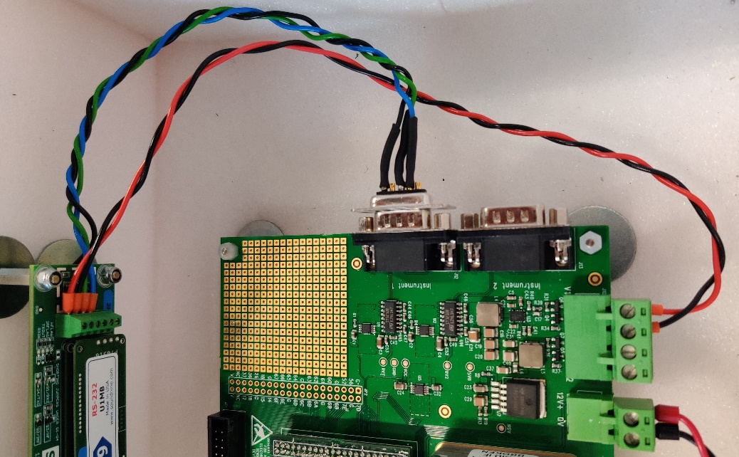
Remove the surface modem serial port from the data logger mainboard (blue circle; screws will need removing) and attach directly to a PC using a serial cable and a serial-USB converter. Before each SBE 37-IM can be configured, the ID of the internal inductive modem must be set. The ID number must be unique and must not clash with the ID of any other instrument. The ID must be in the range of 01-99. The steps required to set the ID differ depending on the type of surface modem used: Soundnine or Seabird.
Soundnine Surface Ultimodem
For a Soundnine surface Ultimodem Open Tera Term and set the New Connection properties to Serial and select the COM port that corresponds to the serial-USB converter. The correct COM port can be found in the Windows Device Manager. Click OK and then select Setup from the top menu bar, followed by Serial port…. Change the settings to match the following (ignoring Port which will be different), and then click New setting.
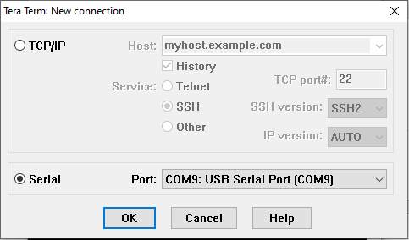
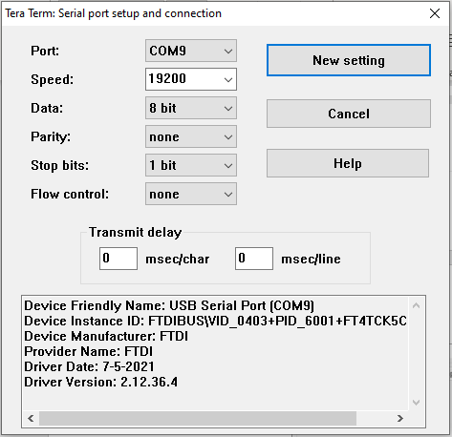
In the terminal, press enter a few times and the surface Ultimodem should respond with:
PWRUP

S9>
S9>
...
Once a connection has been made with the surface Ultimodem, type fcl into the terminal and press enter. This stands for “Force Capture Line”, which captures the IM network and sends a wakeup tone to the instruments attached to the inductive loop such that they start listening for commands on the IM network. This connection will time out after 60 seconds of inactivity, and you will need to type fcl to capture the line again if this occurs. To determine the ID of the instrument currently attached to the test loop, type ID?
<Remote>
id = 01
</Remote>
<qs>972093</qs>

OK; 16 Events

S9>

In the example above, the instrument has an ID of 01. To change the device ID, type !XXSetDeviceID=YY, where XX is the existing ID and YY is the new device ID in the range of 01-99. Confirm that the new ID has been set by running ID? again.
Once the ID has been set, the instrument is ready to be configured. Run the following commands in order: #XXDATETIME=12122014123200 where XX is the ID of the instrument sets the internal clock. The datetime takes the format MMDDYYYYHHmmSS. Set the time as accurately as possible to the PC clock, which should be set to UTC with no time zone correction or daylight saving. If the clock can’t be set, make sure the instrument is not logging by sending the #XXSTOP command.
#XXOUTPUTFORMAT=1 where XX is the ID of the instrument sets the data format to converted decimal data.
#XXINITLOGGING where XX is the ID of the instrument initialises logging and deletes all existing samples in the memory. Repeat this command when prompted.
#XXSAMPLEINTERVAL=[sample rate] where XX is the ID of the instrument sets the instrument sampling rate in seconds.
#XXSTARTDATETIME=12122014130000 where XX is the ID of the instrument sets the sampling start date and time. The datetime takes the format MMDDYYYYHHmmSS. Ensure that all instruments are set to the same start time.
#XXSTARTLATER where XX is the ID of the instrument, programmes the instrument to begin logging at the start time set above.

SBE 37-SM CTD (serial)
Following the instructions in the SBE 37-SM MicroCAT manual, remove the endcap from the instrument, disconnect the communication cable, and remove the batter holder. Insert 12 AA batteries into the battery holder, following the polarity instructions. Replace the battery holder, reconnect the communications cable and reattach the endcap to the main body.
Each SBE37-SM needs to be configured for deployment through the terminal. Connect each SBE37_SMP in turn to a PC using the Seabird provided serial cable and a serial-USB converter. Open Tera Term and set the New Connection properties to Serial and select the COM port that corresponds to the serial-USB converter. The correct COM port can be found in the Windows Device Manager. Click OK and then select Setup from the top menu bar, followed by Serial port…. Change the settings to match the following (ignoring Port which will be different), and then click New setting.
In the terminal, press enter a few times and the SBE37_SMP should respond with:
<Executed/>

Once a connection has been, the instrument is ready to be configured. Run the following commands in order: DATETIME=12122014123200 sets the internal clock. The datetime takes the format MMDDYYYYHHmmSS. Set the time as accurately as possible to the PC clock, which should be set to UTC with no time zone correction or daylight saving. If the clock can’t be set, make sure the instrument is not logging by sending the #XXSTOP command.
OUTPUTFORMAT=1 sets the data format to converted decimal data.
INITLOGGING initialises logging and deletes all existing samples in the memory. Repeat this command when prompted.
SAMPLEINTERVAL=[sample rate] sets the instrument sampling rate in seconds.
STARTDATETIME=12122014130000 sets the sampling start date and time. The datetime takes the format MMDDYYYYHHmmSS. Ensure that all instruments are set to the same start time.
STARTLATER programmes the instrument to begin logging at the start time set above.

RBRconcerto CTD
Carefully unscrew the RBRconcerto endcap. Take extra care of the “telephone” cable that connects the endcap to the body of the instrument. This can become brittle in cold environments, so it is worth warming up the instrument before attempting to open it. Once the endcap is open, open the battery compartment and insert 8 AA batteries following the polarity instructions on the battery compartment lid. Close the battery compartment and plug in the USB cable. Connect the instrument to the computer through the USB port.
The RBRconcerto stores and outputs data in a variety of formats, however the data logger expects specific formats to be used. For the RBRconcerto’s internal memory, it must be configured to use the EasyParse (calbin00) format, or else it won’t be able to communicate with the data logger. For direct output from the RBRconcerto, it must be configured to use the caltext01 format. These formats may already have been set, but you should double checking before the instrument is configured for deployment. To check the configuration, open Tera Term and set the New Connection properties to Serial and select the RBR instrument USB-CDC interface:
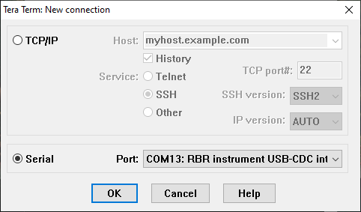
The COM port number will differ between computers. Click OK and then select Setup from the top menu bar, followed by Serial port…. Change the settings to match the following (ignoring Port which will be different), and then click New setting.
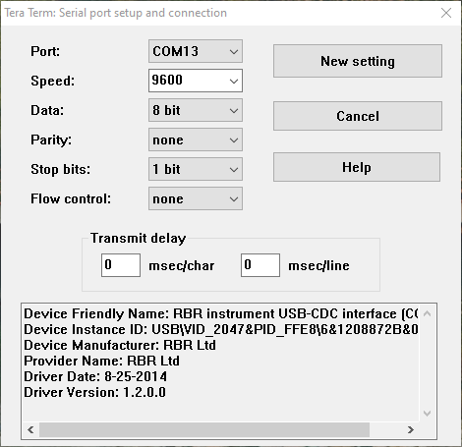
A connection should now be established with the RBRconcerto. Press enter a few times and the instrument should respond with
Ready:
If the instrument does not respond with Ready:, but does respond to other commands such as id, it is possible that the prompt state has been turned off. Try changing the prompt state with
prompt state = on
There is no input echo, so the command you are typing will not be printed to the screen, but the instrument should respond with
prompt state = on
Ready:
Once you are connected to the instrument and have a Ready: prompt, type memformat into Tera Term and press enter. The instrument should respond with:
memformat type = calbin00, newtype = calbin00, availabletypes = rawbin00|calbin00
Verify that newtype is set to calbin00. The RBRconcerto has a 10-second sleep timeout, so if it responds to the memformat command with Ready:, issue the memformat command again as the instrument has gone to sleep. If newtype is not set to calbin00, type the following command into Tera Term and then press enter to configure the RBRconcerto to use the EasyParse (calbin00) format:
memformat newtype = calbin00
Verify the command was successful by issuing the memformat command again and check the value of newtype.
Once the RBRconcerto is configured to use the EasyParse (calbin00) format for its internal memory, we can check the format it will use for direct output using
outputformat
The instrument should respond with (the label list might vary)
outputformat type = caltext01, labelslist = conductivity_00|temperature_00|pressure_00|seapressure_00|depth_00|salinity_00|speedofsound_00|specificconductivity_00

If the output format type is not set to caltext01, change the format using
outputformat type = caltext01
Verify the command was successful by issuing the outputformat type command again and verify the value. Once the data formats are set, close Tera Term and open Ruskin to configure the instrument for deployment. Ruskin should automatically detect and connect to the attached instrument. If it doesn’t, try disconnecting and reconnecting the USB cable. First, sync the clock in the instrument by clicking on the UTC button. Then change Power, Sampling, Gating and Options settings to match those below:
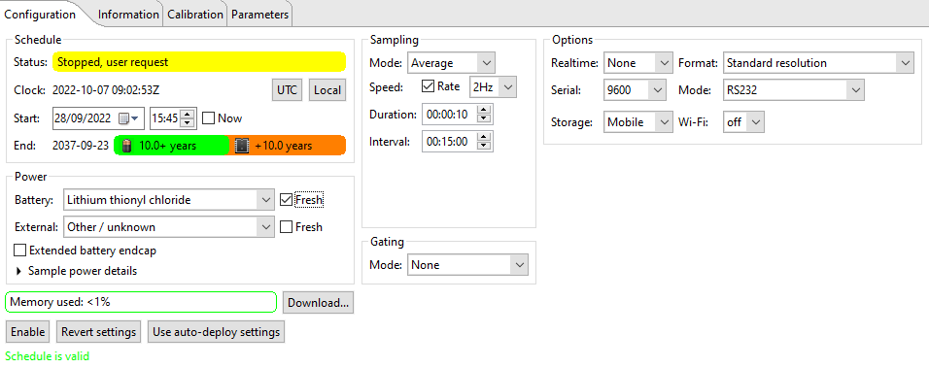

These options will configure the instrument to take a 10 second sample burst at a rate of 2 Hz every 15 minutes, providing a single average value at the end of the burst. Modify the Start parameter to initiate sampling at a specified time and date in UTC, taking note of the constraints discussed earlier in the section on sampling schedules. Click Enable and then Erase and enable logging to start the instrument deployment. The instrument Status should change to Schedule enabled
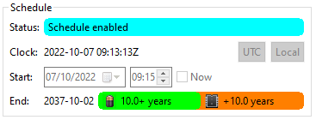

Disconnect the USB cable, make sure the endcap is plugged into the main instrument body and then carefully screw the endcap onto the main body. The instrument is now ready for deployment.
The RBRconcerto is compatible with a range of additional sensors to measure parameters such as optical dissolved oxygen (ODO), turbidity, backscatter, chlorophyll A, and fluorescence etc. Additional sensors for that are currently supported by the data logger include the RBRcoda T.ODO|slow and the RBRtridente. To use additional sensors with an RBRconcerto, the RBR_CTD_aux_sens_1 and RBR_CTD_aux_sens_2 key-value pairs must be set in the configuration file to specify which sensors are attached to each concerto interrogated by the logger, and in which order data from the additional sensors appear in the concerto data stream. The sensor type is specified using a numeric flag taken from the table below, and the flag for the additional sensor that responds first should be inserted into RBR_CTD_aux_sens_1, while the additional sensor that responds second should be inserted into RBR_CTD_aux_sens_2.
Additional Sensor | Numeric Flag
RBRcoda T.ODO|slow | 01
RBRtridente | 02
To determine the order in which the additional sensors respond in the data stream, attach the instrument to a PC using a USB cable and open Ruskin. Select the Information tab and examine the list of Channels.
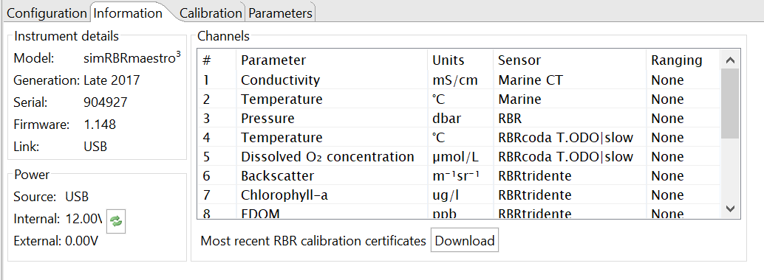
The first few channels will be those associated with the concerto’s CTD, and these will be followed by the channels associated with the additional sensors. In the example above, data from the RBRcoda T.ODO|slow appears first in the data stream, followed by data from the RBRtridente. In this case, the flag for the RBRcoda T.ODO|slow should be entered into RBR_CTD_aux_sens_1, while the flag for the RBRtridente should be entered into RBR_CTD_aux_sens_2.
If no RBRconcertos that are to be interrogated by the logger have any additional sensors attached, then RBR_CTD_aux_sens_1 and RBR_CTD_aux_sens_2 do not need to be defined. If there is a mix, with some RBRconcertos having additional sensors and some not, then a flag must be specified for each concerto, with 0 indicating that no additional sensors are attached to a particular concerto. For example, three concerto’s are attached to a mooring and are interrogated in the following order: RBR_CTD_IM_ID = “F4”, “B6”, “A3”. B6 has no additional sensors attached, while F4 and A3 have an RBRcoda T.ODO|slow and RBRtridente. For F4 the RBRcoda T.ODO|slow responds first, while in A3 the RBRtridente responds first. In this scenario, the RBR_CTD_aux_sens key-value pairs should be set as follows: RBR_CTD_aux_sens_1 = 1, 0, 2 and RBR_CTD_aux_sens_2 = 2, 0, 1.

RBRcoda T.ODO
Using the provided 6-pin pigtail, attach the RBRcoda T.ODO to a PC using a serial port or USB-serial converter and apply 12 V power to the instrument. Open Ruskin to configure the instrument for deployment. Ruskin should automatically detect and connect to the attached instrument. If it doesn’t, try disconnecting the reconnecting the serial/USB cable. Change the Realtime, Sampling and Power settings to match those below:
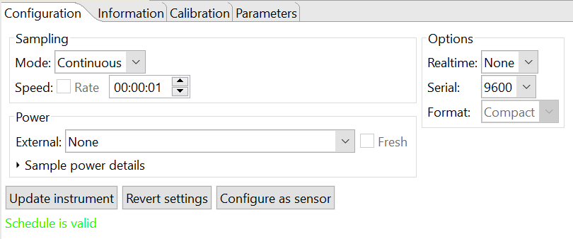
Click Update instrument for the settings to take effect and then close Ruskin.
The RBRcoda T.ODO stores and outputs data in a variety of formats, however the data logger expects specific formats to be used. To check the configuration of the output format, open Tera Term and set the New Connection properties to Serial and select the correct COM port to which the instrument is attached. The COM port number will differ between computers. Click OK and then select Setup from the top menu bar, followed by Serial port…. Change the settings to match the following (ignoring Port which will be different), and then click New setting.
A connection should now be established with the RBRcoda T.ODO. Press enter a few times and the instrument should respond with
Ready:
If the instrument does not respond with Ready:, but does respond to other commands such as id, it is possible that the prompt state has been turned off. Try changing the prompt state with
prompt state = on
There is no input echo, so the command you are typing will not be printed to the screen, but the instrument should respond with
prompt state = on
Ready:
Once you are connected to the instrument and have a Ready: prompt, type outputformat into Tera Term and press enter. The instrument should respond with:
outputformat type = caltext06
If the output format is not set to caltext06, type the following command into Tera Term and then press enter:
outputformat type = caltext06
The instrument should respond with
outputformat type = caltext06
Ready:
To confirm that the output format has been set to caltext06. The instrument is now ready for deployment.

Nortek Aquadopp
Using the tools provide by Nortek, remove the endcap from the main instrument body. Keeping the end plug cable attached, install the dual lithium battery pack using the battery splitter cable. The batteries can be tight, and it may take a few attempts to seat them correctly alongside the splitter cable and the dessicant pack. Replace the endcap.
Connect the instrument to a PC using the Nortek serial cable and a serial-USB converter. Open Nortek Aquadopp DW to configure the instrument for deployment. Ensure the software is configure for the correct COM port by navigating to Communication in the top menu bar and selecting Serial port…. Set the COM port to match that of the serial-USB converter and set the baud rates to those shown below.
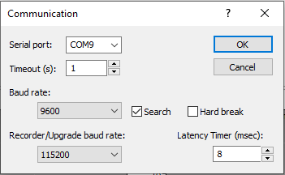
Navigate to Deployment in the top menu bar and select Planning followed by Load from Instrument. Under the Standard tab, configure the settings to match those below:
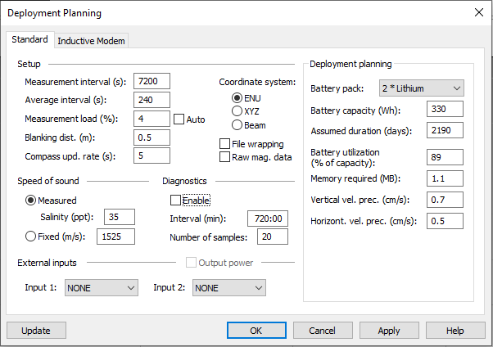
These settings will configure the instrument to sample every two hours with a 4 minute (240 second) averaging period. Be careful to disable the Diagnostics output. With two lithium batteries, this gives a battery life of over 6 years (2190 days). Note these Deployment planning figures are not communicated to the instrument – the just give confidence in the length of the battery life. If the Aquadopp has an internal inductive modem, click on the Inductive Modem tab, and enable the inductive modem. Give the modem a unique Device ID between 01 and 99, set the Transmit power level to High and the Data format to ASCII.
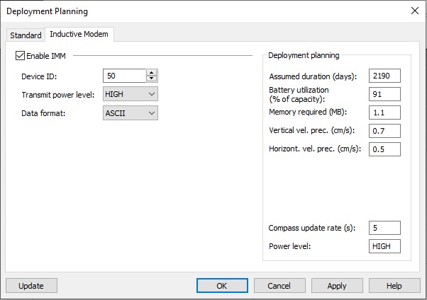
Once the settings are configured, click the Update button to send them to the instrument. The Aquadopp DW software will provide a prompt showing that the instrument was successfully configured.
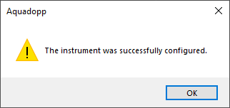
Erase any existing data on the logger by selecting Deployment from the top menu bar followed by Erase Recorder… Click Yes to confirm
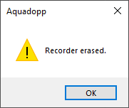
To initiate sampling, select Deployment from the top menu bar, followed by Start Recorder Deployment. Select Start At and modify the time and date fields to initiate sampling at a specified time in UTC, taking note of the constraints discussed earlier in the section on sampling schedules. Once the time and date are set, give the deployment a name (max six characters) and click OK.
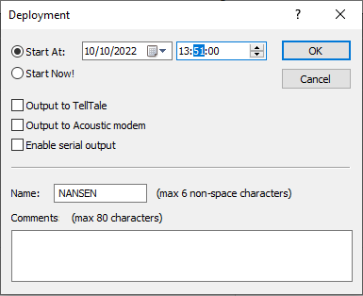
Choose whether you wish to save the deployment configuration file
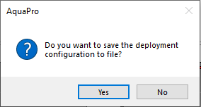
and then click Yes to set the clock to PC time. This sets the clock to the local PC time, so make sure you PC time zone is configured for UTC.
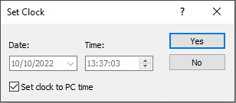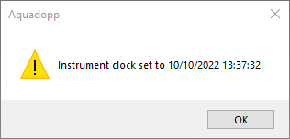
Click OK to confirm the instrument clock setting, and then Confirm to start the deployment using the current settings at the specified time and date.
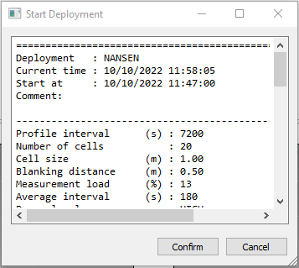
Click OK on any warnings stating that the instrument is unable to open the log file, and the instrument will then provide confirmation that sampling will start at the specified time and date.
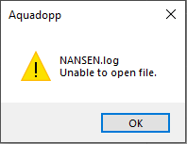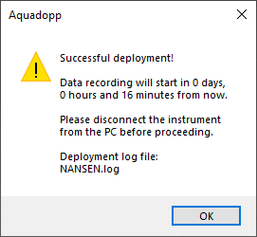

Nortek Aquadopp Profiler
Using the tools provide by Nortek, remove the endcap from the main instrument body. Keeping the end plug cable attached, install the dual lithium battery pack using the battery splitter cable. The batteries can be tight, and it may take a few attempts to seat them correctly alongside the splitter cable and the dessicant pack. Replace the endcap.
Connect the instrument to a PC using the Nortek serial cable and a serial-USB converter. Open Nortek AquaPro to configure the instrument for deployment. Navigate to Deployment in the top menu bar and select Planning followed by Load from Instrument. Under the Standard and Advanced tab, configure the settings to match those below:
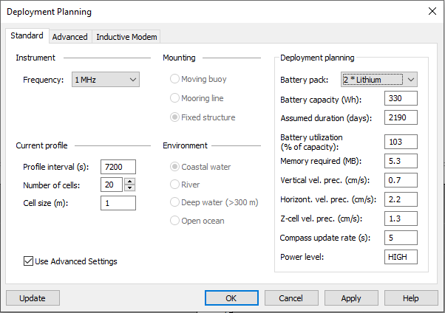
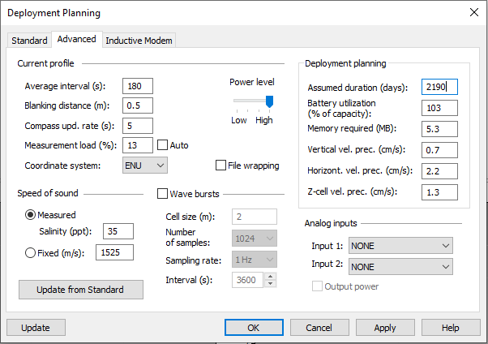
These settings will configure the instrument to sample every two hours with a 3 minute (180 second) averaging period. Velocity will be recorded in 20 individual bins, with a bin depth of 1 m and blanking distance of 0.5 m. With two lithium batteries, this gives a battery life of just under 6 years (2190 days). Note these Deployment planning figures are not communicated to the instrument – the just give confidence in the length of the battery life. Once the settings are configured, click the Update button to send them to the instrument. The AquaPro software will provide a prompt showing that the instrument was successfully configured.
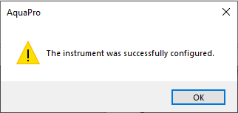
Erase any existing data on the logger by selecting Deployment from the top menu bar followed by Erase Recorder… Click Yes to confirm
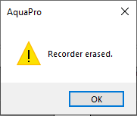
To initiate sampling, select Deployment from the top menu bar, followed by Start Recorder Deployment. Select Start At and modify the time and date fields to initiate sampling at a specified time in UTC, taking note of the constraints discussed earlier in the section on sampling schedules. Once the time and date are set, give the deployment a name (max six characters) and click OK.
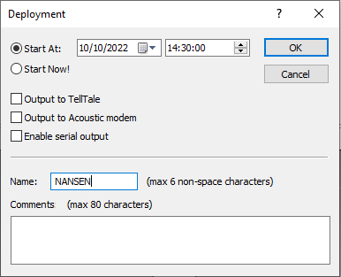
Choose whether you wish to save the deployment configuration file
and then click Yes to set the clock to PC time. This sets the clock to the local PC time, so make sure you PC time zone is configured for UTC.
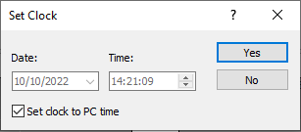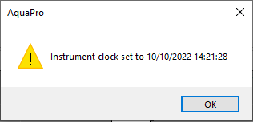
Click Confirm to start the deployment using the current settings at the specified time and date.
Click OK on any warnings stating that the instrument is unable to open the log file, and the instrument will the provide confirmation that sampling will start at the specified time and date.
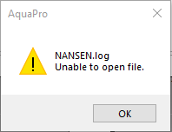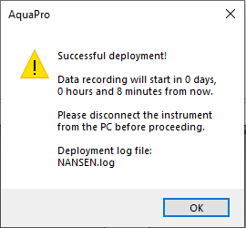

Impact Subsea ISA 500
Attach the provided PC pigtail to the ISA 500 and plug the serial port into a computer using a serial cable and a USB to serial converter. Apply 12 V of power to the instrument by attaching the white wire of the PC pigtail to the positive terminal of a 12 V battery/power supply and the black wire of the PC pigtail to the negative terminal of a 12 V battery/power supply. Open the SeaView software. Click the 3x3 square button in the bottom left and select ISA 500 and then press Ok.

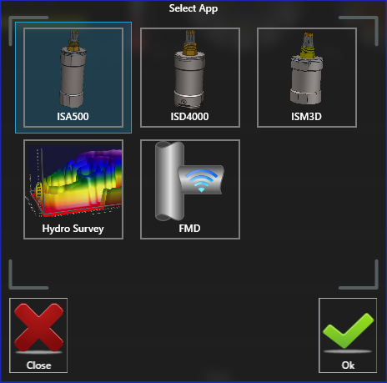
Click Connect and configure the serial settings to match the COM port of the USB to serial converter and the baud rate to 9600. Click >> Connect <<.

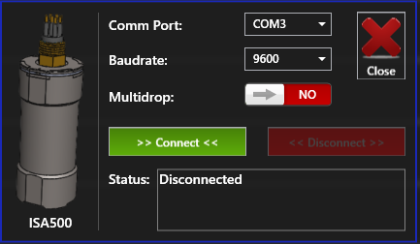
In the Status: box, SeaView should now show that it is connected to the instrument:
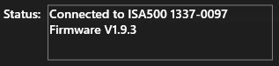
Click the Close red cross to return to the main SeaView screen. If you move the ISA 500, the Heading, Pitch, and Roll numbers at the top right of the SeaView screen should be updating in real time. Open the instrument settings by clicking on the ISA 500 cog. Navigate through the instrument settings by pressing on the orange left and right arrows. Confirm the settings match the following:

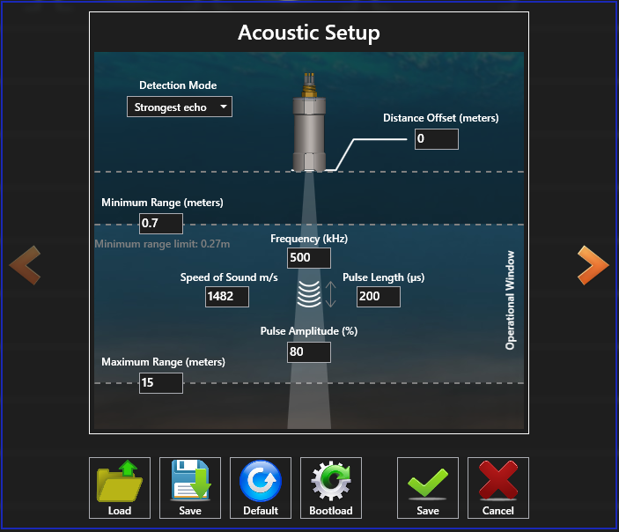
In the Acoustic Setup, pick an appropriate Speed of Sound
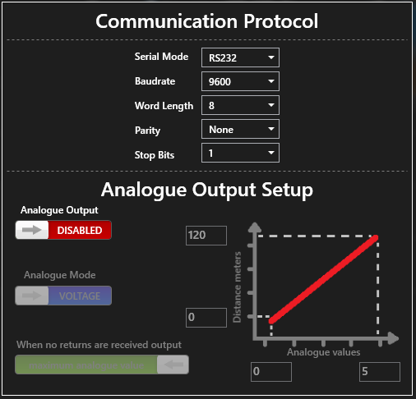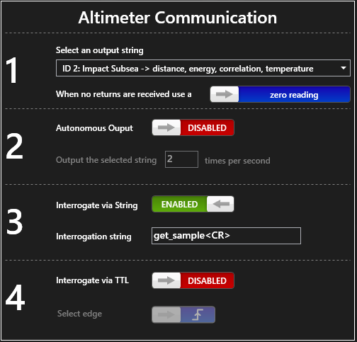
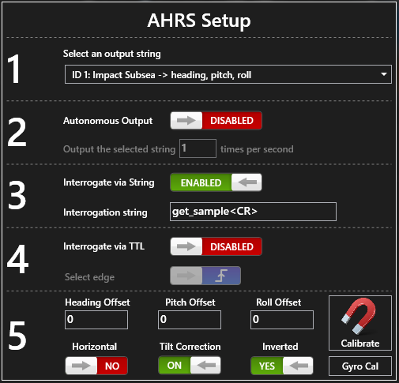
Once the instrument is fully configured, click the green Save tick. The instrument can now be disconnected from the PC and is ready for deployment. As the ISA 500 is not internally recording, the sampling schedule is controlled exclusively by the logger and there is no risk of the logger schedule clashing with the instrument sampling schedule.

Soundnine XT
The Soundnine XT sensor requires no configuration prior to deployment. It does not record data internally and therefore the sampling schedule is controlled exclusively by the logger. There is no risk of the logger schedule clashing with the instrument sampling schedule.

Soundnine Inductive Modem Configuration
Before deployment, the components of the Soundnine inductive system (Surface data logger Ultimodem and Underwater Ultimodems) need to be assigned a unique ID and specifically configured for each instrument type to which they are attached. The unique ID allows each Underwater Ultimodem to be addressed individually by the data logger, and it is imperative that the correct termination characters and communication timeouts are specified for each instrument type to ensure successful communications. The following sections detail the setup requirements for the Soundnine inductive modem system.

Batteries and Desiccant Packs
Before deployment, batteries need to be inserted into each underwater Ultimodem, along with a fresh desiccant pack. Unscrew the top of each underwater Ultimodem using the provided tool and insert 2 or 6 batteries into the battery holder depending on the model of the modem, taking care to ensure the correct polarity of the batteries. Using electrical tape, secure two new desiccant packs on the backside of the battery holder. Once the batteries and desiccant are secured in place, close the Ultimodem and tighten the end cap using the tool provided. The endcap of the Ultimodem needs to be gently pushed into the body of the modem before the screw threads will engage.
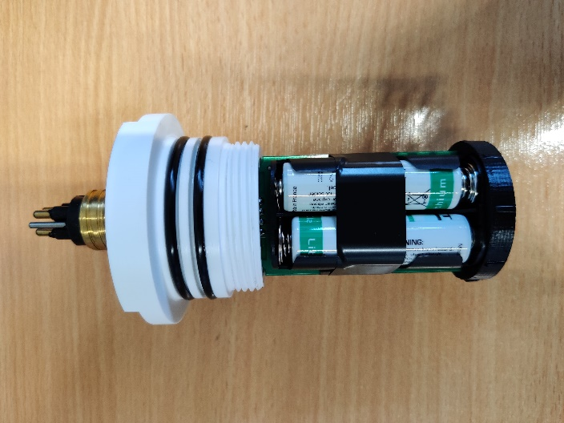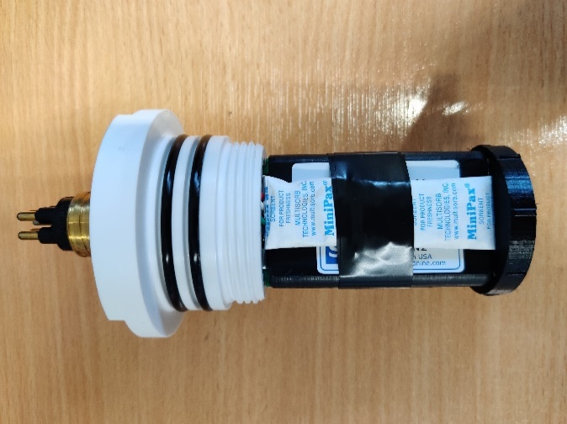

Ultimodem ID & Configuration
Each underwater Ultimodem needs to be assigned and unique ID and specifically configured for the instrument to which it is attached. To change the ID and configuration of an underwater Ultimodem, it is necessary to first power on and directly connect to the Soundnine surface Ultimodem contained in the data logger.
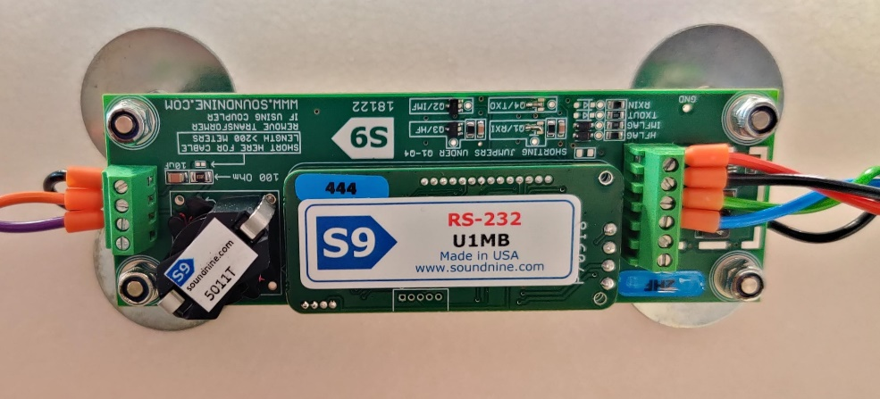
Unscrew the black-red twisted power cable that connects the surface modem to the data logger mainboard (red circle) and attach directly to a 12V power supply. Remember the correct positive/negative orientation of the power cable in the mainboard to avoid electrically shorting the modem when it is reconnected.
Remove the surface modem serial port from the data logger mainboard (blue circle; screws will need removing) and attach directly to a PC using a serial cable and a serial-USB converter. Open Tera Term and set the New Connection properties to Serial and select the COM port that corresponds to the serial-USB converter. The correct COM port can be found in the Windows Device Manager. Click OK and then select Setup from the top menu bar, followed by Serial port…. Change the settings to match the following (ignoring Port which will be different), and then click New setting.
In the terminal, press enter a few times and the surface Ultimodem should respond with:
PWRUP

S9>
S9>
...
Pressing enter should result in the modem printing the S9> prompt to the screen. To view the current modem configuration, type fcl and press enter, followed by !XXgetcd and enter. XX is the ID of the modem you want to configure, fcl tells the surface Ultimodem to “force capture” the inductive modem line (an error will be printed if you forget to do this), and getcd is the “get configuration data command”. The modem should respond by printing all the configuration settings to the screen.
To change a configuration setting, use either !XX[setting]=[value] or !XX[setting] [value]. For example, to change the baud rate to 9600 on an underwater Ultimodem with an ID of 40 use either !40baud=9600 or !40baud 9600. Changing the wrong configuration settings can make the modem unresponsive or unable to read data from specific instruments, so take extreme care when typing and issuing the commands. To confirm that a setting has taken effect, use the getcd command to print the updated configuration settings to the screen.
Each underwater Ultimodem also requires a unique ID that allows it to be addressed by the datalogger. The ID is a two-element alpha-numeric string drawn from the hexadecimal number system that ranges from 0 to 9 and A to F. Selecting alpha-numeric characters outside of this range will prevent correct identification of the modem in the Iridium SBD messages and may corrupt the SBD message entirely. Examples of valid IDs include F4, 1A, 45, AB. The ID of an underwater Ultimodem can be changed using either !XXID=YY or !XXID YY, where XX is the current ID of the underwater Ultimodem and YY is the new ID that is required.
Once the underwater Ultimodem is correctly configured, disconnect the surface modem serial port from the PC and reconnect to the serial port on the data logger mainboard. Ensure it is plugged into the same port from which it was removed. Remove the 12V power supply to the surface modem and reattach the power cables to the mainboard connector, paying close attention to the polarity of the wires.
In the following sections the Ultimodem configuration settings required for each instrument type are listed. Ignore the id and group fields as these will vary between instruments of the same type.

OEM Surface Ultimodem
<Config type='Ultimodem' sn='U1D7' v='0'>
<Hardware>
<Assembly>5016C</Assembly>
<Firmware>ULTIMODEM V0.99V</Firmware>
</Hardware>
<Settings>
baud=19200
mod=1200 baud@4.8k (1)
id=D7
group=0
wakeupsrc=RS232 Only (1)
hostPrompt=S>
modemPrompt=S9>
cmdTO=60
asyncRx=1
telMode=2
hostWakeup=0
termFromHost=13
termToHost=254
thost0=0
thost1=5
thost2=3000
thost3=12000
thost4=500
thost5=5
tmodem2=500
tmodem3=18000
icd=1
echo=1
sflow=1
debuglevel=0
imfConfig=0
setagc=0
</Settings></Config>

RBRconcerto CTD
<Config type='Ultimodem' sn='U0XF' v='0'>
<Hardware>
<Assembly>50109</Assembly>
<Firmware>ULTIMODEM V0.99V</Firmware>
</Hardware>
<Settings>
baud=9600
mod=4800 baud@19.2k (4)
id=MJ
group=0
wakeupsrc=IM Only (2)
hostPrompt=S>
modemPrompt=S9>
cmdTO=60
asyncRx=1
telMode=3
hostWakeup=0
termFromHost=0
termToHost=13
thost0=0
thost1=5
thost2=300
thost3=12000
thost4=100
thost5=5
tmodem2=500
tmodem3=18000
icd=1
echo=1
sflow=0
debuglevel=0
imfConfig=0
setagc=0
</Settings></Config>

RBRcoda T.ODO
<Config type='Ultimodem' sn='U0XF' v='0'>
<Hardware>
<Assembly>50109</Assembly>
<Firmware>ULTIMODEM V0.99V</Firmware>
</Hardware>
<Settings>
baud=9600
mod=4800 baud@19.2k (4)
id=MJ
group=0
wakeupsrc=IM Only (2)
hostPrompt=S>
modemPrompt=S9>
cmdTO=60
asyncRx=1
telMode=3
hostWakeup=0
termFromHost=0
termToHost=13
thost0=0
thost1=5
thost2=300
thost3=12000
thost4=100
thost5=5
tmodem2=500
tmodem3=18000
icd=1
echo=1
sflow=1
debuglevel=0
imfConfig=0
setagc=0
</Settings></Config>

Nortek Aquadopp
<Config type='Ultimodem' sn='U0XF' v='0'>
<Hardware>
<Assembly>50109</Assembly>
<Firmware>ULTIMODEM V0.99V</Firmware>
</Hardware>
<Settings>
baud=9600
mod=4800 baud@19.2k (4)
id=F4
group=0
wakeupsrc=IM Only (2)
hostPrompt=S>
modemPrompt=S9>
cmdTO=60
asyncRx=1
telMode=3
hostWakeup=0
termFromHost=0
termToHost=13
thost0=0
thost1=5
thost2=300
thost3=12000
thost4=100
thost5=5
tmodem2=500
tmodem3=18000
icd=1
echo=1
sflow=0
debuglevel=0
imfConfig=0
setagc=0
</Settings></Config>

Nortek Aquadopp Profiler
<Config type='Ultimodem' sn='U0XF' v='0'>
<Hardware>
<Assembly>50109</Assembly>
<Firmware>ULTIMODEM V0.99V</Firmware>
</Hardware>
<Settings>
baud=9600
mod=4800 baud@19.2k (4)
id=F4
group=0
wakeupsrc=IM Only (2)
hostPrompt=S>
modemPrompt=S9>
cmdTO=60
asyncRx=1
telMode=3
hostWakeup=0
termFromHost=0
termToHost=13
thost0=0
thost1=5
thost2=300
thost3=12000
thost4=100
thost5=5
tmodem2=500
tmodem3=18000
icd=1
echo=1
sflow=0
debuglevel=0
imfConfig=0
setagc=0
</Settings></Config>

Impact Subsea ISA 500
<Config type='Ultimodem' sn='U0XF' v='0'>
<Hardware>
<Assembly>50109</Assembly>
<Firmware>ULTIMODEM V0.99V</Firmware>
</Hardware>
<Settings>
baud=9600
mod=4800 baud@19.2k (4)
id=A1
group=0
wakeupsrc=IM Only (2)
hostPrompt=S>
modemPrompt=S9>
cmdTO=60
asyncRx=1
telMode=3
hostWakeup=0
termFromHost=0
termToHost=13
thost0=0
thost1=5
thost2=300
thost3=12000
thost4=100
thost5=5
tmodem2=500
tmodem3=18000
icd=1
echo=1
sflow=1
debuglevel=0
imfConfig=0
setagc=0
</Settings></Config>

RBR Inductive Modem Configuration
Before deployment, the components of the RBR inductive system (Head End Modem; HEM and Sub Surface Modems; SSM) need to be properly configured, and the ID numbers of the SSMs attached to the inductive loop need to be stored in the HEM EEPROM. The data logger utilises the “transparent connection” option provided by the RBR inductive system to communicate with each instrument on the inductive loop and download the data stored in their internal memory. While in this mode, data and commands received by the HEM and/or an SSM through their serial port is buffered internally in the HEM/SSM before being sent to an instrument (SSM), over the inductive link (SSM to/from HEM) or back to the data logger (HEM). There are three possible options for triggering the HEM or SSM to transmit their internal buffer:
- Wait until a “send character” has been received by the HEM/SSM.
- Wait for a defined period of inactivity on the HEM/SSM serial port.
- Wait until the transmit buffer on the HEM/SSM reaches a size threshold.
The data logger uses a combination of method 1 and method 2. Data/commands are transmitted when the HEM/SSM receives the transparent send character x0A (carriage return), or when the HEM/SSM serial port has been inactive for 150 ms. The latter method ensures that responses from instruments that are not terminated with the transparent send character (i.e. carriage return) are transmitted successfully back to the data logger. The EEPROM in the HEM and SSMs need to be programmed with these parameters so that these operation modes function correctly. The following sections detail the setup requirements for the RBR inductive modem system.

Head End Modem configuration
To configure the RBR Head End Modem it is necessary to power on and directly connect a laptop to the HEM. Using the provided cables, attach the HEM serial port to a PC using a USB serial converter and apply 12 V power to the HEM power port. Open a terminal emulator (RealTerm is preferable for configuring the RBR system as there is no command echo), set the correct serial port settings under the Port tab and click Change. The COM port will differ between PCs.
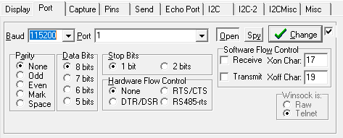
Commands can be sent to the HEM using the Send tab. To confirm that the HEM is connected to the laptop, send A<CR> (unit identification command terminated with a carriage return) to the HEM (click Send ASCII to send the command)
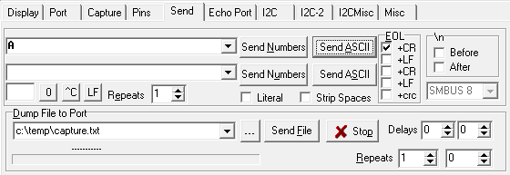
The HEM should respond with RBR SSS-1000 MM.mmm DDDDDD where SSS is “HEM” or “SSM”, MM.mmm is the firmware revision (MM may be a single digit) and DDDDDD is the zero padded 6-digit serial number of the unit. The HEM and SSMs have a default sleep timeout of 10 seconds after no serial port activity has been detected. A command sent to the serial port wakes the HEM if it is asleep, however it may not respond to the command that was sent. If this is the case, and the HEM does not respond immediately to the unit identification command, the command can be sent a second time.
Once the HEM is awake, the ID numbers of the SSMs attached to the inductive loop need to be stored in the HEM EEPROM. Connect all SSMs that will be deployed to a “test” inductive loop (i.e. a loop of wire with a 100 ohm resistor) and connect this to the HEM. Send the DISC<CR> command to the HEM. The HEM should respond with a list of the serial numbers of all the SSMs connected to the system (the command takes several seconds to run) and these serial numbers will be stored in the HEM EEPROM
discovery requested
230444
230427
discovery complete OK

To confirm that the serial numbers have been stored correctly, send the SSM<CR> command to the HEM, which will read back the serial numbers stored in the EEPROM. The number of SSMs and serial numbers should match those attached to the test inductive loop
list of attached SSMs (2):
230444
230427

Once the SSM serial numbers are stored in the HEM EEPROM, the “transparent connection” options on the HEM needs to be configured. Confirm the HEM is awake using the unit identification command, and then issue the following commands in order (do not send the [comments]):
EE TPSNDC 0D<CR> [Set the transparent send character to x0D - carriage return]
EE TPSNDEN 1<CR> [Enable transparent send character mode]
EE TPSNDC2 1<CR> [Enable “send transparent character too” to ensure the transparent send character is also sent on to the SSM/instrument]
EE MDOCDUR 3000<CR> [Set the open channel timeout – in 10ms – to 30 seconds]
EE TPCTO 10<CR> [Set the transparent character timeout to 100 ms]
EE TPCTOEN 1<CR> [Enable transparent character timeout]

Once set, the value of these different parameters can be confirmed by repeating the command without sending a value (e.g. EE TPSNDC or EE TPCTO).

Sub Surface Modem configuration
Alongside the HEM, the serial port parameters and the “transparent connection” options on each SSM attached to the inductive loop need to be separately configured. To configure an SSM, it is necessary to open a connection to the SSM from the HEM using the following command (use the unit identification command to wake the HEM first if necessary).
X ######<cr>
where ###### is the 6-digit zero-padded SSM serial number (i.e. S/N 2325 becomes 002325). Once the connection is open, the HEM will respond with
channel requested (with ssm ######)...GRANTED
The “transparent connection” options are the same for each SSM and don’t depend on the type of instrument the SSM is attached too. To set these options, issue the following commands in order (note the leading “.” – this ensures the commands are executed on the SSM not the HEM):
.EE TPSNDC 0D<CR> [Set the transparent send character to x0D - carriage return]
.EE TPSNDEN 1<CR> [Enable transparent send character mode]
.EE TPSNDC2 1<CR> [Enable “send transparent character too” to ensure the transparent send character is also sent on to the SSM/instrument]
.EE TPCTO 10<CR> [Set the transparent character timeout to 100 ms]
.EE TPCTOEN 1<CR> [Enable transparent character timeout]

To set the correct serial port parameters, issue the following command on each SSM to set the baud rate to 9600. No other parameters need changing.
.EE BAUD 9600<CR>
Once the serial port and “transparent connection” options have been set, their value can be confirmed by repeating the command without sending a value (e.g. .EE TPSNDC or .EE BAUD). Once the SSM is correctly configure, the connection between the HEM and SSM can be closed using
X K<CR>
and the HEM will respond with
channel closed
This process should be repeated until all the SSMs on the inductive loop have been configured.

Data Logger Configuration File
The behaviour of the logger is controlled by the CONFIG.INI configuration file held on the primary SD card inserted into the Card 1 slot on the data logger mainboard. When the logger is first powered up, the configuration file is copied to the secondary SD card and is available if the primary SD card becomes corrupted. It is imperative that the configuration file is correct to ensure a successful deployment.
The configuration file uses the standard INI file format which consists of text-based content with a structure and syntax comprising key-value pairs for each property/setting. For the BAS data logger there are several required key-value pairs, as well as a range of optional key-value pairs depending on which instruments are attached to the logger. A description of each required/optional key-value pair is given below.

Required key-value pairs
Required key-value pairs control the core behaviour of the data logger and must be specified irrespective of which instrument types are attached to the logger.
task_number: tells the data logger how many different types of instrument are attached and need to be added to the sampling schedule. This is a critical parameter and if set incorrectly will cause the deployment to fail. The task_number refers to the number of different types of instruments, not the number of different individual instruments. If the logger detects that the task_number is incorrect, it will attempt to correct it and print a warning to the terminal (if attached).
task_retry: defaults to 2 and sets the number of additional attempts the logger will make to communicate with an instrument/complete a task if the initial attempt fails.
sync_clock_gps: defaults to 1 and determines whether the data logger’s real-time clock will be synchronised with a valid GPS time during housekeeping activities. Set to zero otherwise.
adjust_clock_speed: defaults to 1 and determines whether the speed of the logger real time clock is adjusted daily to minimise clock drift. Set to zero otherwise.
iridium: defaults to 1 and determines whether an exchange of Iridium SBD messages is attempted during housekeeping activities. Set to zero otherwise.
housekeeping: defaults to 1 and determines whether housekeeping activities should take place. The data logger’s clock will be synced to GPS time (see sync_gps), Iridium communications will be attempted (see iridium), and the SD cards will be checked with any errors repaired. Set to zero otherwise.
daily_reset: defaults to 1 and determines whether the data logger resets at the end of the housekeeping activities. Set to zero otherwise.
logon: defaults to 1 and determines whether the log file is generated. This is a text file called LOG.TXT that is maintained on both SD cards. It records the operation of the data logger. Set to zero otherwise.
debug: defaults to 1 and determines whether instrument SBD data should be printed to the terminal and log file. Set to zero otherwise.
max_file_age: maximum data file age in seconds. Defaults to 604,800 (7 days). Very large data files should be avoided for two reasons: if for some reason the file is corrupted, fewer observations will be lost if the file length is shorter; and very long files incur substantial time overheads that can run to many seconds while the file is opened, and the end of file is found. Short files are fine, but there will be a lot of them.
max_sbd_age: maximum time in seconds that Iridium SBD messages will remain in the message queue before being deleted. Defaults to 259,200 (3 days). Large ages should be avoided to prevent the queue becoming blocked. Short periods risk message loss if Iridium communications fail for a few days in a row.
watchdog_task_int: time in seconds after which the data logger will be reset if no operations have occurred and the data logger has not entered sleep mode. The assumption is that a fault has occurred.
housekeeping_int: interval in seconds between housekeeping activities. Defaults to 86,400 (1 day). Housekeeping activities are tied to the real time clock, so the housekeeping activities will occur at the end of the last sampling task before midnight.
serial_timeout: interval in seconds after which serial communications will be halted if no data has been received. Defaults to 10 seconds. Prevents the data logger from ‘locking up’ if an instrument fails to respond in a timely manner.

Optional key-value pairs
The optional key-value pairs in the configuration file control the behaviour of the data logger depending on which different instrument types are attached. Key-value pairs that are not required (i.e. they refer to instrument types that are not attached to the logger) do not have to be specified. Where the key-value pair refers to an integer or character array, the maximum length of the array defaults to 10 elements. For advanced users, this can be adjusted by changing the ID_ARRAY_LENGTH variable in macros.vnm and then reprogramming the logger. A description of each optional key-value pair is given below.

Inductive modem
S9_IM_port: serial port number (1 or 2) to which the Soundnine surface Ultimodem is attached.
S9_IM_ID: comma-separated character array up to ID_ARRAY_LENGTH in length, specifying the ID of each underwater Ultimodem attached to the inductive loop. For example: S9_IM_ID = "F4", "A3".
SBE_IM_port: serial port number (1 or 2) to which the Seabird inductive modem is attached.
RBR_IM_port: serial port number (1 or 2) to which the RBR Head End Modem is attached.
RBR_IM_ID: comma-separated character array up to ID_ARRAY_LENGTH in length, specifying the ID of each RBR Sub Surface Modem attached to the inductive loop. For example: RBR_IM_ID = "232057", "232059".

Soundnine XT
S9_XT_int: two-element comma-separated integer array determining how often the Soundnine XT sensor groups should be polled by the data logger in seconds. The first and second elements in the array specify the polling interval for group 0 and group 1 sensors, respectively. For example: S9_XT_int = 3600, 600 will poll group 0 XT sensors every 3600 seconds (1 hour), and group 1 XT sensors every 600 seconds (10 minutes). If only group 0 sensors are being used, set S9_XT_int to a single element array specifying the polling interval for group 0 sensors only.
S9_XT_sbd_int: single integer specifying how often in seconds samples from XT sensors in group 0 and group 1 (if required) should be averaged and included in the Iridium SBD messages.
S9_XT_groups: single integer specifying the number of different S9_XT sensors groups attached to the inductive loop (1 or 2).
S9_XT_sensors: two element comma-separated integer array specifying the number of sensors in each S9_XT sensor group. If only group 0 sensors are being used, specify S9_XT_sensors as a single element array specifying the number of instruments in group 0.
S9_XT_SBD_ID: comma-separated character array up to ID_ARRAY_LENGTH in length, determining which Soundnine XT sensors from both group 0 and group 1 should be included in the Iridium SBD messages. Sensors are specified by their serial numbers and omit the leading X. For example: S9_XT_SBD_ID = "0AG", "0AN".

SBE 37-IM CTD (inductive modem)
SBE_37IM_int: two element comma-separated integer array determining (1): how often the Seabird SBE_37IM sensors should be polled by the data logger in seconds, and (2): the SBE_37IM sampling interval in seconds. For example: SBE_37IM_int = 7200, 3600 will poll the SBE_37IM sensors every 7200 seconds (2 hours) which are sampling every 3600 seconds (1 hour).
SBE_37IM_IM_ID: comma-separated character array up to ID_ARRAY_LENGTH in length, specifying the inductive modem ID of each SBE_37IM instrument. For example: SBE_37IM_IM_ID = "20", "22".

SBE 37-SM CTD (serial)

RBRconcerto CTD
RBR_CTD_int: single integer determining how often the RBRconcerto CTD sensors should be polled by the data logger in seconds. For example: RBR_CTD_int = 7200 will poll the RBRconcerto CTD sensors every 7200 seconds (2 hours).
RBR_CTD_IM_ID: comma-separated character array up to ID_ARRAY_LENGTH in length, specifying the inductive modem IDs of the RBRconcerto CTD instruments. For example: RBR_CTD_IM_ID = "F4", "A3".
RBR_CTD_skip_arch: comma-separated Boolean (0 or 1) array up to ID_ARRAY_LENGTH in length, specifying whether existing samples on the RBRconcerto CTD instruments should be ignored, and sample fetching should begin at the current write point rather than at the beginning of the memory block. This configuration parameter is useful when restarting data loggers that have already been deployed for a substantial period.
RBR_CTD_aux_sens_1: comma separated integer array up to ID_ARRAY_LENGTH in length, specifying whether an additional sensor is attached to the RBRconcerto CTD. Additional sensors specified in this key-value pair indicate that they are the first additional sensor to respond in the data stream.
RBR_CTD_aux_sens_2: comma separated integer array up to ID_ARRAY_LENGTH in length, specifying whether an additional sensor is attached to the RBRconcerto CTD. Additional sensors specified in this key-value pair indicate that they are the second additional sensor to respond in the data stream.

RBRcoda T.ODO
RBR_TODO_int: single integer determining how often the RBRcoda T.ODO sensors should be polled by the data logger in seconds. For example: RBR_TODO_int = 7200 will poll the RBRcoda T.ODO sensors every 7200 seconds (2 hours).
RBR_TODO_sbd_int: single integer specifying how often in seconds samples from RBRcoda T.ODO sensors should be averaged and included in the Iridium SBD messages.
RBR_TODO_IM_ID: comma-separated character array up to ID_ARRAY_LENGTH in length, specifying the inductive modem IDs of the RBRcoda T.ODO sensors. For example: RBR_TODO_IM_ID = "F4", "A3".

Nortek Aquadopp
Nortek_AQD_int: single integer determining how often the Nortek Aquadopp sensors should be polled by the data logger in seconds. For example: Nortek_AQD_int = 7200 will poll the Nortek Aquadopp sensors every 7200 seconds (2 hours).
Nortek_AQD_IM_ID: comma-separated character array up to ID_ARRAY_LENGTH in length, specifying the inductive modem IDs of the Nortek Aquadopp instruments. For example: Nortek_AQD_IM_ID = "F4", "A3".
Nortek_AQD_int_IM: comma-separated Boolean (0 or 1) array up to ID_ARRAY_LENGTH in length, specifying which Nortek Aquadopps have an internal inductive modem.
Nortek_AQD_skip_arch: comma-separated Boolean (0 or 1) array up to ID_ARRAY_LENGTH in length, specifying whether existing samples on the Nortek Aquadopp instruments should be ignored, and sample fetching should begin at the current write point rather than at the beginning of the memory block. This configuration parameter is useful when restarting data loggers that have already been deployed for a substantial period.

Nortek Aquadopp Profiler
Nortek_AQP_int: single integer determining how often the Nortek Aquadopp Profiler sensors should be polled by the data logger in seconds. For example: Nortek_AQP_int = 7200 will poll the Nortek Aquadopp Profiler sensors every 7200 seconds (2 hours).
Nortek_AQP_IM_ID: comma-separated character array up to ID_ARRAY_LENGTH in length, specifying the inductive modem IDs of the Nortek Aquadopp Profiler instruments. For example: Nortek_AQP_IM_ID = "F4", "A3".
Nortek_AQP_skip_arch: comma-separated Boolean (0 or 1) array up to ID_ARRAY_LENGTH in length, specifying whether existing samples on the Nortek Aquadopp Profiler instruments should be ignored, and sample fetching should begin at the current write point rather than at the beginning of the memory block. This configuration parameter is useful when restarting data loggers that have already been deployed for a substantial period.

Nobska MAVS
Nobska_MAVS_int: single integer determining how often the Nobska MAVS sensors should be powered on, and velocity data sampled by the data logger in seconds. For example: Nobska_MAVS_int = 7200 will power on the Nobska MAVS sensors every 7200 seconds (2 hours).
Nobska_MAVS_port: serial port number (1 or 2) to which a single Nobska MAVS is attached.
Nobska_MAVS_period: single integer determining the length of the Nobska MAVS sampling period.
Nobska_MAVS_compass: single Boolean (1, 0) specifying whether the compass module is activated in the Nobska MAVS configuration settings.

Impact Subsea ISA 500
ISA_500_int: two element comma-separated integer array determining (1): how often the Impact Subsea ISA 500 sensors should be polled by the data logger in seconds, and (2): the number of pings requested during each sampling period. For example: ISA_500_int = 7200, 10 will poll the Impact Subsea ISA 500 sensors every 7200 seconds (2 hours), requesting 10 pings.
ISA_500_port: serial port number (1 or 2) to which a single Impact Subsea ISA 500 is attached. This key-value pair should not be specified if an ISA 500 is not attached via the serial port.
ISA_500_IM: Boolean (0 or 1) specifying whether the Impact Subsea ISA 500 sensors are attached to inductive modems.
ISA_500_IM_ID: comma-separated character array up to ID_ARRAY_LENGTH in length, specifying the inductive modem IDs of the Impact Subsea ISA 500 instrument. For example: ISA_500_IM_ID = "F4".

SBD Iridium Communications
The data logger contains an Iridium modem that can send a subset of data back from the field using the Iridium Short Burst Data (SBD) service. It is also possible to reconfigure the logger remotely over the SBD service, allowing the logger sampling interval to be reduced or increased depending on the capacity of the battery at the surface. Internal sampling schedules for instruments deployed beneath the ice shelf cannot be modified. The SBD system is bandwidth limited and each SBD message can hold a total of 330 bytes of data. The data logger has been programmed to compress sample data as much as possible, but care must be taken to ensure that only a realistic subset of the data is returned each day.

Data messages
The frequency at which samples are added to the SBD data buffer is controlled by the logger schedule for each instrument task in the configuration file. The more frequent the logger schedule, the more samples that will be added to the SBD buffer. For instruments that internally record (e.g. RBR and SBE CTDs, and Nortek current meters), a single sample will be added to the SBD buffer each time the logger downloads the latest data from the instrument. If the logger fetches more than one sample in each download period, an average of all the samples fetched from the logger will be added to the SBD buffer. For instruments that are not internally recording (e.g. Soundnine XT sensors), an additional interval parameter is specified in the configuration file to specify the frequency at which a sample should be added to the SBD buffer. The sample is the average of all the observations taken in the period between each SBD sample. For instruments that provide a velocity profile (e.g. Nortek Aquadopp Profiler), the average of the velocity profile is added to the SBD sample. For turbulence resolving instruments (e.g. Nobska MAVS), the burst averaged values are added to the SBD sample.
The number of bytes required by each sample varies by instrument and is set out in the table below. These figures can be used to calculate a daily data budget based on the number of instruments attached to the logger and the specified sampling interval. In addition to the data samples, 22 bytes of housekeeping data (e.g. logger temperature, voltage, location etc.) is sent via SBD each day, and each individual SBD message requires an additional header overhead of 4 + (2 × number of instrument types attached to the logger) bytes. This additional overhead may increase the number of SBD messages required if your data budget (instrument samples & housekeeping) is close to a multiple of 330 bytes. A data budget requiring 3-5 SBD messages per day is a reasonable target to aim for.
SBD messages are sent over the Iridium uplink at the end of each housekeeping period. By default, this is once pay day and occurs at the end of the first scheduled instrument sampling period after midnight. The logger automatically compiles all the data (samples and housekeeping) in the SBD buffer into individual SBD messages, which get saved to the end of the SBD message queue. The logger then attempts to send each of the SBD messages in the queue (starting with the oldest) over the Iridium uplink until the queue is empty, or
Instrument | Total number of bytes | Data fields and size
Seabird SBE 37-IM | 16 | Sensor ID (1 byte)  Timestamp (4 bytes)  Conductivity (3 bytes)  Temperature (3 bytes)  Pressure (3 bytes)  Voltage (2 bytes)
RBRconcerto CTD | 16 (CTD)  +6 (RBRcoda T.ODO)  +9 (RBRtridente) | Sensor ID (1 byte)  Timestamp (4 bytes)  Conductivity (3 bytes)  Temperature (3 bytes)  Pressure (3 bytes)  Voltage (2 bytes)
RBRcoda T.ODO | 14 | Sensor ID (1 byte)  Timestamp (4 bytes)  Temperature (3 bytes)  Oxygen conc (3 bytes)  Optode phase (3 bytes)
Soundnine XT | 15 (XT sensors)  21 (XIM-CTD sensors) | Sensor ID (2 bytes)  Sensor format (1 byte)  Timestamp (4 bytes)  Temperature (3 bytes)  Pressure (3 bytes; XIM-CTD only)  Conductivity (3 bytes; XIM-CTD only)  Voltage (2 bytes)  Tilt (3 bytes)
Nortek Aquadopp | 18 | Sensor ID (1 byte)  Timestamp (4 bytes)  u velocity (2 bytes)  v velocity (2 bytes)  w velocity (2 bytes)  Pressure (3 bytes)  Temperature (2 bytes)  Voltage (2 bytes)
Nortek Aquadopp Profiler | 18 | Sensor ID (1 byte)  Timestamp (4 bytes)  u velocity (2 bytes)  v velocity (2 bytes)  w velocity (2 bytes)  Pressure (3 bytes)  Temperature (2 bytes)  Voltage (2 bytes)
Impact Subsea ISA 500 | 15 | Timestamp (4 bytes)  Range (3 bytes)  Energy (2 bytes)  Correlation (2 bytes)  Pitch (2 bytes)  Roll (2 bytes)
Nobska MAVS | 24 | Timestamp (4 bytes)  u velocity (3 bytes)  v velocity (3 bytes)  w velocity (3 bytes)  Temperature 1 (3 bytes)  Temperature 2 (3 bytes)  Conductivity (3 bytes)  Sample count (2 bytes)
the Iridium uplink fails. If the uplink fails, messages are retained in the queue until they are older than the max_sbd_age parameter specified in the configuration file. Messages older than the max_sbd_age parameter are deleted before the uplink begins to ensure individual SBD messages do not permanently block the queue.
A MATLAB programme is available to decode the housekeeping data and instruments samples contained in the SBD messages once they have been received. This code automatically accounts for any missing messages that the data logger was unable to send, so the loss of instrument and housekeeping data should not extend beyond the samples that were contained in the missing message.

Configuration messages
The settings defined in the data logger configuration file can be reconfigured remotely by sending the new configuration information in an email to data@sbd.iridium.com. The subject should contain the data logger’s Iridium modem IMEI number (e.g. 300234010700342) and the message should have no body. The new configuration data should be formatted as a CONFIG.INI file and attached to the email as base-64 encoded attachment. The contents of the attachment must follow all the rules associated with .ini files, with an additional constraint that it must not exceed 270 bytes in length. Its contents should therefore be limited to the settings that need to be changed. The extension for the attachment must be .SBD.
The data logger will check for a remote configuration file whenever it enters the SBD exchange process at the end of its housekeeping tasks. If the remote configuration is successfully received, the data logger will send another message containing the updated configuration. This acts as confirmation that the update has been received and actioned. If a sequence of remote configuration messages have been sent to the data logger, these will be received and read sequentially, and the data logger will send a confirmation configuration message for each remote message received.
To save data, the confirmation configuration message uses abbreviated field names which are detailed in the table below.

Abbreviation | Configuration parameter | Abbreviation | Configuration parameter
TN | task_number | APID | Nortek_AQP_IM_ID
S9IMP | S9_IM_port | APSA | Nortek_AQP_skip_arch
S9IM | S9_IM_ID | MI | Nobska_MAVS_int
RBIMP | RBR_IM_port | MP | Nobska_MAVS_port
RBIM | RBR_IM_ID | MPR | Nobska_MAVS_period
SBIMP | SBE_IM_port | MC | Nobska_MAVS_compass
S9I | S9_XT_int | ISI | ISA_500_int
S9SI | S9_XT_sbd_int | ISP | ISA_500_port
S9G | S9_XT_groups | ISIM | ISA_500_IM
S9S | S9_XT_sensors | ISID | ISA_500_IM_ID
S9ID | S9_XT_SBD_ID | TR | task_retry
SBI | SBE_37IM_int | SC | sync_clock_gps
SBID | SBE_37IM_IM_ID | CS | adjust_clock_speed
RBCI | RBR_CTD_int | IR | Iridium
RBCID | RBR_CTD_IM_ID | HK | housekeeping
RBCSA | RBR_CTD_skip_arch | DR | daily_reset
RBOI | RBR_TODO_int | LO | logon
RBOSI | RBR_TODO_sbd_int | DB | debug
RBOID | RBR_TODO_IM_ID | FA | max_file_age
ADI | Nortek_AQD_int | SA | max_sbd_age
ADID | Nortek_AQD_IM_ID | WD | watchdog_task_int
ADIM | Nortek_AQD_int_IM | HK | housekeeping_int
ADSA | Nortek_AQD_skip_arch | ST | serial_timeout
API | Nortek_AQP_int

SD Card Endurance
The endurance of the SD cards depend on the size of the SD cards themselves, as well as the number of instruments sampled by the data logger and the sampling interval of each instrument. The table below details the space required on the SD card each time the logger fetches a sample(s) from an instrument as a function of the communication method used (i.e. type of inductive modem or direct serial connection). Some instruments (e.g. RBRconcerto CTD and Nortek Aquadopp) return a single sample each time they are polled by the data logger, and therefore a single value for the number of bytes required each time the logger fetches a sample is provided. For other instruments (e.g. Seabird SBE 37-IM and Soundnine XT sensors), multiple samples are returned each time the logger polls the instrument depending on the number of instruments attached to the inductive loop or the difference between the sampling rate of the instrument and the rate at which it is polled by the data logger. For these instruments, a simple algorithm is provided to calculate the data usage. The length of the sample returned by some instruments can vary by small amounts (e.g. Nortek Aquadopp or RBRcoda T.ODO), and therefore endurance calculations should considered as indicative only and larger SD cards should be considered if space is becoming limited.
 | Space required (bytes)
 | Communication method
Instrument | Soundnine IMM |  | RBR IMM | Direct serial connection
Seabird SBE_37IM | 190 +  64 × sample number |  | - | -
RBRconcerto CTD | 304 |  | 146 | -
RBRcoda T.ODO | 230 |  | - | -
Soundnine XT | 72 + 87 × XT number + 139 × XIM-CTD number |  | - | -
Nortek Aquadopp | Internal IMM | External IMM | External IMM | -
Nortek Aquadopp | 338 | 232 | 95 | -
Nortek Aquadopp Profiler | 442 |  | 265 | -
Impact Subsea ISA 500 | 235 |  | - | 109
Nobska MAVS | - |  | - | 110 (no compass)  130 (compass)

Real-Time Data During Mooring Deployment
Experience has shown that during deployment of a mooring through a hot water-drilled borehole, it is useful to know the instantaneous temperature, conductivity, and pressure from any compatible instrument on the string. This allows more accurate placement of the instruments with respect to the ice base or the seabed. Currently this functionality is only available for RBRconcerto and SBE 37-IM CTDs.
To acquire real-time samples, the logger must be connected to the inductive loop through the primary or secondary I/O port on the side of the data logger, depending on which port the inductive modem is attached to. Attach the Terminal (TTL) cable to the data logger mainboard (orientate the connector such that the missing wire aligns with the VCC pin) and plug into a PC via USB. Move the Prog (2) DIP switch to On. Open the Venom IDE and select Terminal from the top menu bar, followed by Terminal Settings…. Set the correct COM port and click OK (leave all other settings unchanged). If a box in the bottom left of the IDE shows Closed, select Terminal from the top menu bar, followed by Open/Close COM Port (more details can be found in the Preparing the Data Logger section).
Apply 12 V power to the logger using a battery or DC power supply and turn it on using the power switch on the side. In the Venom IDE, the terminal should respond with:
VM2 Control Computer running Venom2 at 72MHz
### PRE-RELEASE
Version 2023 05 24
Copyright 2023 Venom Control Systems Ltd.

Application in Flash: Erase Application?
Press N to confirm that we don’t wish to delete the programme currently stored in the logger’s flash memory. Type init and press enter in the terminal to initialise the logger, ensuring that an SD card with a valid configuration is present in the Card 1 slot. Once the logger has finished initialising and the prompt (-->) has been returned, a real time sample can be acquired using one of the following commands
RBRconcerto CTD: RBR_CTD.get_single_sample(“XX”)
where XX is the inductive modem ID of the instrument from which you want the sample. An example response looks like:
RBR_CTD sample from instrument XX
---------------------------------
Timestamp 2023-07-24 10:56:42
Conductivity: 2.1659
Temperature: -1.1496
Pressure: 543.5957

SBE37IM CTD: SBE_37IM.get_single_sample(“XX”)
where XX is the inductive modem ID of the instrument from which you want the sample. An example response looks like:
SBE_37IM sample from instrument XX
----------------------------------
Timestamp 2023-07-24 10:56:42
Conductivity: 2.1659
Temperature: -1.1496
Pressure: 543.5957

Deploying the Data Logger

Power System and Antenna Setup
Before the data logger can be deployed, the power system must be assembled and attached to the data logger. The power system consists of a solar panel and batteries of varying sizes and number, as well as a charge controlled if required. Dig a snow pit approximately 1 m deep with a lip that can be covered with a sheet of plywood. Placing the data logger and battery in a pit helps prevent excessive chilling of the electronics by winter cold spikes.
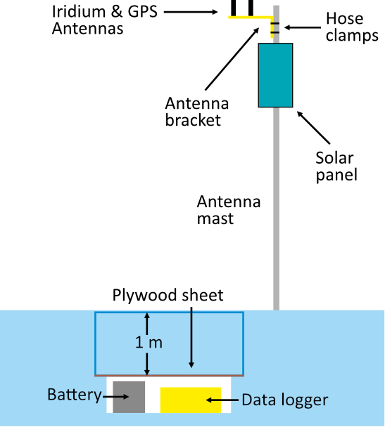
Assemble the solar panel (facing true North) and GPS/Iridium antennas on a glacier pole mast. The metallic pole will have no effect on the performance of the antennas. Use hose clamps (Jubilee clips) to fix the antenna bracket to the mast. Use a washer or two beneath the bracket when connecting the antennas. the antennas need to be screwed down tightly enough to draw the O-ring firmly onto the top of the bracket, but not so tight as to damage the antenna. If no washers are used, the connector will come to the end of the thread before the O-ring has been drawn onto the bracket. If too many washers are used, the O-ring will sit beautifully, but the connector might not be properly engaged electrically. Experience shows that either no washers or one washer is required. Ensure the solar panel, Iridium and GPS cables are neatly clipped to the mast every 300 mm or so using cable ties or equivalent to avoid them whipping in the wind.
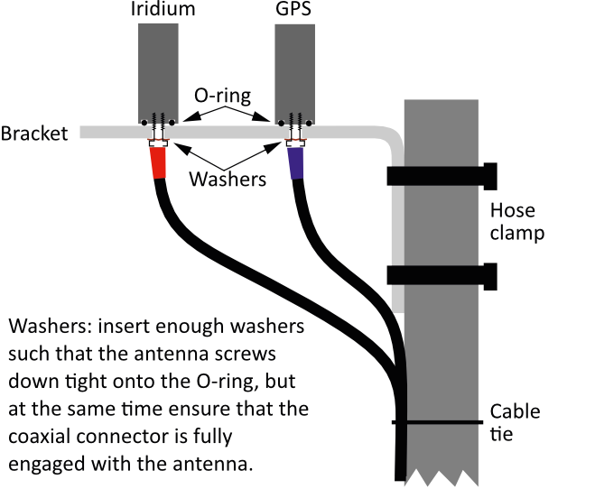
Erect the mast, using guy ropes to secure the glacier pole and attach the solar panel cable directly to the battery or the charge controller. Place the battery in the snow pit. Attach the data logger to the battery or charge controller using the power cable, ensuring the correct polarity. Careful, there is not polarity protection in the data logger. Attach the GPS (blue) and Iridium (red) antennas cables to the data logger and finally attach the instrument cables to the Primary and Secondary I/O ports.

GPS and Iridium Communication Checks
GPS and Iridium communications are central to smooth operation of the data logger. Once the logger has been setup with the power system and the GPS and Iridium antennas are attached, communications can be fully tested before the data logger is left to overwinter.
To test the communications, attach the Terminal (TTL) cable to the data logger mainboard (orientate the connector such that the missing wire aligns with the VCC pin) and plug into a PC via USB. Move the Prog (2) DIP switch to On. Open the Venom IDE and select Terminal from the top menu bar, followed by Terminal Settings…. Set the correct COM port and click OK (leave all other settings unchanged). If a box in the bottom left of the IDE shows Closed, select Terminal from the top menu bar, followed by Open/Close COM Port (see preparing the logger for more information).
Apply 12 V power to the logger using a battery or DC power supply and turn it on using the power switch on the side. In the Venom IDE, the terminal should respond with:
VM2 Control Computer running Venom2 at 72MHz
### PRE-RELEASE
Version 2023 05 24
Copyright 2023 Venom Control Systems Ltd.

Application in Flash: Erase Application?
Press N to confirm that we don’t wish to delete the programme currently stored in the logger’s flash memory. Type init and press enter in the terminal to initialise the logger, ensuring that an SD card with a valid configuration is present in the Card 1 slot. Once the logger has finished initialising and the prompt (-->) has been returned, the logger is ready for the communication checks.

GPS
To test GPS communications, type GPS.get_test_fix() in the terminal and press enter. The logger will wait up to 120 seconds to get a valid GPS fix and will print the results to the terminal. A valid fix that confirms that GPS communications are working correctly will look like this:
2022-11-01-151937: test_gps_fix - Attempting to obtaining GPS fix
2022-11-01-152017: test_gps_fix - GPS fix successful
2022-11-01-152017: test_gps_fix - VM2 timestamp 2022-11-01 15:20:17
2022-11-01-152017: test_gps_fix - GPS timestamp 2022-11-01 15:20:21
2022-11-01-152018: test_gps_fix - GPS latitude +52.2116
2022-11-01-152018: test_gps_fix - GPS longitude +000.0799

If the GPS communications fail, the result printed to the terminal will look like this:

2022-11-01-151937: test_gps_fix - Attempting to obtaining GPS fix
2022-11-01-152400: test_gps_fix - GPS fix failed

Iridium
To test Iridium communications, type Iridium.test_sbd_exchange() in the terminal and press enter. The logger will create a test Iridium SBD message from housekeeping data (e.g. logger position, logger temperature, logger voltage etc.) and will attempt to send this message via the Iridium modem. Iridium communications require a working GPS connection, so make sure to test and confirm the GPS functionality first. The logger will attempt to send the SBD message three times and will print the results to the terminal. A successful transmission on the first attempt (i.e. SBD exchange is started only once) will look like this:
2022-11-01-152540: test_SBD_exchange - Attempting to send SBD message
2022-11-01-152540: test_SBD_exchange - Attempting to obtain GPS fix
2022-11-01-153003: test_SBD_exchange - GPS fix successful
2022-11-01-153003: test_SBD_exchange - Battery voltage: 10.97
2022-11-01-153004: test_SBD_exchange - Logger temperature: 21.73
2022-11-01-153004: test_SBD_exchange - GPS latitude: +52.2120
2022-11-01-153004: test_SBD_exchange - GPS longitude: +000.0802
2022-11-01-153005: test_SBD_exchange - GPS timestamp: 2022-11-01 15:30:07
2022-11-01-153005: test_SBD_exchange - VM2 timestamp: 2022-11-01 15:30:03
2022-11-01-153006: Iridium - Transferring message to ISU
2022-11-01-153007: Iridium - ISU response: READY
2022-11-01-153007: Iridium - Transfer to ISU code: 0
2022-11-01-153007: Iridium - Starting SBD exchange
2022-11-01-153013: Iridium - Signal strength: +CSQ:5,OK
2022-11-01-153018: Iridium - ISU response: +SBDI: 1, 12898, 0, 0, 0, 0,OK
2022-11-01-153018: Iridium - SBDExchange MO Status: 1
2022-11-01-153019: Iridium - SBDExchange MT Status: 0
2022-11-01-153019: Iridium - Successful transmission of SBD message

A failed transmission after three attempts (i.e. SBD exchange is started three times) will look like this:

2022-11-01-152824: test_SBD_exchange - Attempting to send SBD message
2022-11-01-152829: test_SBD_exchange - GPS fix successful
2022-11-01-152830: test_SBD_exchange - Battery voltage: 10.94
2022-11-01-152830: test_SBD_exchange - Logger temperature: 21.88
2022-11-01-152830: test_SBD_exchange - GPS latitude: +52.2120
2022-11-01-152831: test_SBD_exchange - GPS longitude: +000.0803
2022-11-01-152831: test_SBD_exchange - GPS timestamp: 2022-11-01 15:28:33
2022-11-01-152831: test_SBD_exchange - VM2 timestamp: 2022-11-01 15:28:29
2022-11-01-152832: Iridium - Transferring message to ISU
2022-11-01-152833: Iridium - ISU response: READY
2022-11-01-152833: Iridium - Transfer to ISU code: 0
2022-11-01-152834: Iridium - Starting SBD exchange
...
2022-11-01-152852: Iridium - SBD exchange failed
2022-11-01-152854: Iridium - Starting SBD exchange
...
2022-11-01-152901: Iridium - SBD exchange failed
2022-11-01-152902: Iridium - Starting SBD exchange
...
2022-11-01-152925: Iridium - SBD exchange failed
2022-11-01-152926: test_SBD_exchange - SBD message exchange NOT successful

... indicates additional lines of text printed to the terminal that have been omitted for brevity.

Switching on the Logger
Before switching on the logger for deployment, it is recommended to connect the terminal (TTL) cable to the data logger mainboard, such that the flow of data from the instruments can be confirmed through the Venom IDE. See Preparing the Data Logger for details on making the connection. Make sure the Prog (2) DIP switch is set to Off, and that there is copy of the CONFIG.INI file on the primary SD card in the Card 1 slot (blue in following image). Make sure there are no other files on this SD card. Erase all files (including the configuration file) from the secondary SD card and insert it into the Card 2 slot (red in following image). Turn the power switch to on. The red LED on the VM2 Microcontroller should start flashing, and log messages will be printed to the Venom IDE if the logger is connected to a PC. The logger will immediately enter a complete round of sampling. Ensure that the logger successfully samples all instruments before entering sleep mode. Once the logger has entered sleep mode, the terminal (TTL) cable can be removed, and logger box closed. It is now ready for deployment. Place the plywood cover over the snow pit and gently cover with snow. This will prevent the cover from being iced-over due to snow melt and will aid digging during servicing/recovery.
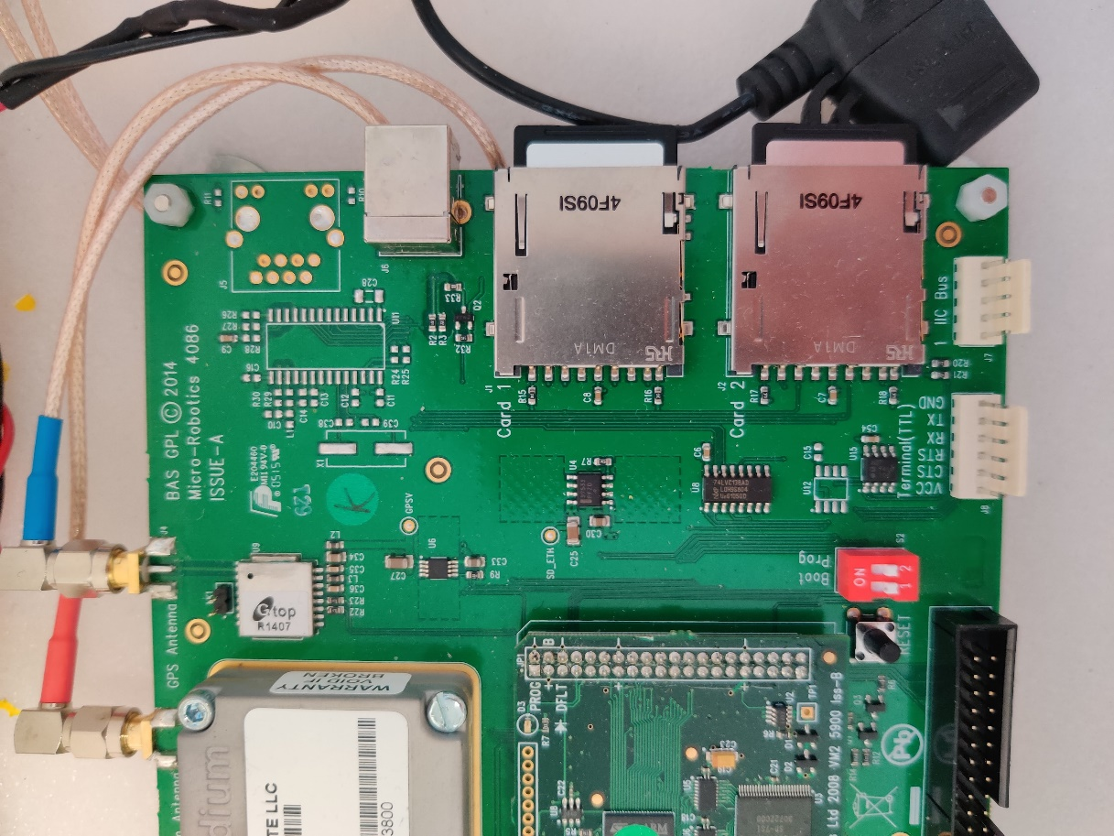

Appendix 1 – Task Scheduler Codes
Task | Name | Code
Seabird SBE 37-IM | SBE_37IM | 1
RBR Concerto CTD | RBR_CTD | 2
Soundnine XT | S9_XT | 3
Nortek Aquadopp | Nortek_AQD | 4
Nortek Aquadopp Profiler | Nortek_AQP | 5
Impact Subsea ISA 500 | ISA_500 | 6
Nobska MAVS | Nobska_MAVS | 7
RBR Coda T.ODO | RBR_TODO | 8

