Determination of dissolved oxygen in seawater by Winkler Titration

Validation of the CTD Oxygen Sensor
With: “Relou”
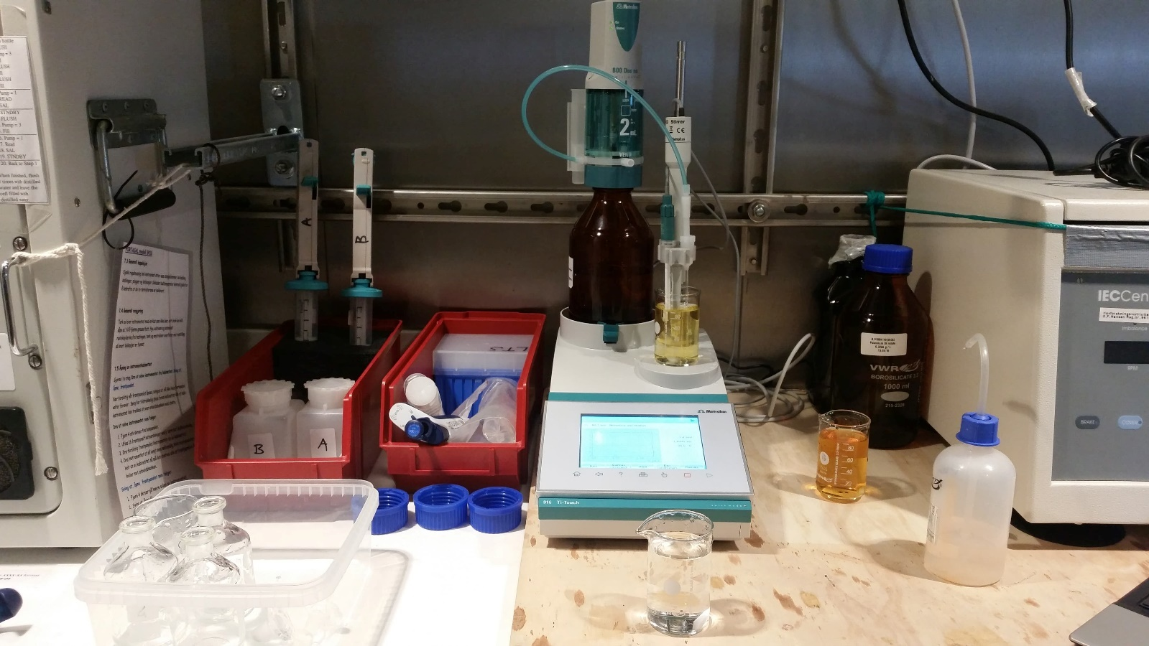
Figure 1: Winkler titration system "Relou" Metrohm Ti-Touch 916, Picture: Claire Mourgues

1. SCOPE 3
2. PRINCIPLE OF THE WINKLER METHOD 3
3. VOLUMETRIC KARL FISHER TITRATION WITH A DOUBLE PT-WIRE ELECTRODE WITH A BIVOLTAMETRIC END POINT DETERMINATION 3
a) What is Karl Fischer Titration? 3
b) Bivoltametric (volumetric) Karl Fisher titration 3
4. EQUIPMENT AND INSTRUMENTS 4
5. REAGENTS AND PREPARATION 4
c) Manganous chloride (3 M): Reagent A 4
d) Sodium iodide (4 M)/Sodium hydroxide (8 M): Reagent B 4
e) Sulfuric acid (5 M): 4
f) Thiosulfate (0,05N): 5
g) Potassium iodate (0.00167 M or 0.0100 N): 5
6. SECURITY AND SAFETY 5
7. QUALITY CONTROL AND MEASUREMENT UNCERTAINTY 5
8. PROCEDURE SAMPLING 5
9. TITRATION PROCEDURES 7
a) Prepare the Metrohm Ti-Touch 916 7
b) Reagent blank determination (Need to be done before each sequence) 8
c) Standardization of thiosulfate solution (Need to be done every week) 9
d) Titration 10
10. MODIFY / ACCESS / PARAMETERS TO A METHOD 11
11. CALCULATION OF OXYGEN CONTENT 13
12. DATA STORAGE 13
13. REFERENCES 13
14. HYDROGRAPHIQUE LOG 14

Figure 1: Winkler titration system "Relou" Metrohm Ti-Touch 916, Picture: Claire Mourgues 1
Figure 2: Wood box with precalibrated Pyrex flasks, Picture: Claire Mourgues 4
Figure 3: Materiel to dispense reagent A and B during the sampling, Picture: Claire Mourgues 6
Figure 4: Oxygen sampling bottles after adding Winkler reagents A and B. High conc. to the left, low conc. to the right. Notice how the bottles and the caps are designed to avoid air bubbles. Picture: Lars-Johan Naustvoll 7
Figure 5: Schematic configuration of propeller stirrer, electrode and buret tip (left) and Picture of the dosing system (left, Picture: Claire Mourgues) 8
Figure 6: Materiel for the reagent blank determination, picture: Claire Mourgues 8
Figure 7: Dispenser for reagents A, B and for H₂SO₄ (left), Picture of the magnet stirrer to mix the sample between each adding (right), picture: Claire Mourgues 9
Figure 8: Materiel for the thiosulfate standardization, picture: Claire Mourgues 9
Figure 9: Picture of the sample transfert 10
Figure 10: Initial volume (ml) function of the dissolved oxygen CTD value (ml.l⁻¹) 10

SCOPE
This protocol describes procedures to be used for the determination of dissolved oxygen in discrete samples of seawater. These procedures are based on the Winkler titration method (Langdon 2010). This procedure is suitable for the measurement of the full range of oceanic oxygen concentrations (0-400 µmol kg-1) in uncontaminated seawater (Langdon 2010).
In our case, the determination of dissolved oxygen in seawater by the Winkler titration will validate the CTD Oxygen sensor. Therefore, you will analyze two stations par week and you will compare the results with the CTD values. You will determinate the dissolved oxygen for 3 depths and you will sample 4 replicates for each depth. You need to choose the water mass with the lowest dissolved oxygen concentration (where the CTD sensor is the less stable) and the water mass with the highest level. You need to choose a depth with a stable dissolved oxygen condition. Before each sequence, you need to determinate your reagent blank and to calibrate your thiosulfate solution.
The Langdon (2010) paper describe a procedure to determinate dissolved oxygen concentration with a very high precision. In our case, we don’t need this level of precision, so several procedure steps have been removed.

PRINCIPLE OF THE WINKLER METHOD
Manganous chloride (MnCl₂) solution is added to a known quantity of seawater and is immediately followed by the addition of an alkaline sodium hydroxide-sodium iodide solution (NaOH/NaI). Manganous hydroxide (Mn(OH)₂) precipitates and reacts with the dissolved oxygen in the water with the formation of a hydrated tetravalent oxide of manganese (MnO(OH)₂).

Mn²⁺ + 2OH– → Mn(OH)₂
2Mn(OH)₂ + O₂ → 2MnO(OH)₂

Upon acidification, the manganese hydroxides dissolve. In the acid solution, the tetravalent manganese in MnO(OH)₂ acts as an oxidizing agent and liberates iodine (I₂) from the iodide ions (I⁻).

2MnO(OH)₂ + 8H⁺ + 4I– → 2Mn²⁺ + 2I₂ + 6H₂O

Two moles of I₂ are formed for each mole of O₂ present in the sample. The amount of I₂ in the solution is determined by titration with a standardized sodium thiosulfate (Na₂S₂O₃) solution.

I₂ + 2S₂O₃²⁻ → 2I– + S₄O₆²⁻

Two moles of thiosulfate are required to titrate each mole of I₂. Since two moles of I₂ were formed for each mole of O₂ the final stoichiometry is four moles of thiosulfate equals one mole of O₂. By knowing the concentration of the thiosulfate solution and the volume required to titrate the liberated I₂ the amount of the oxygen dissolved in the seawater sample can be easily computed.

VOLUMETRIC KARL FISHER TITRATION WITH A DOUBLE PT-WIRE ELECTRODE WITH A BIVOLTAMETRIC END POINT DETERMINATION

What is Karl Fischer Titration?
The Karl Fischer Titration is a titration method for measuring water content in basically all types of substances. It was invented in 1935 by the German chemist Karl Fischer. The Karl Fischer Titration is based on an iodine / iodid reaction: The water reacts with iodine. The endpoint of the titration is reached when all the water is consumed. In the case of the dissolved oxygen Winkler titration, the analyte is iodine (I₂) in acid condition (H₂SO₄) and will react with a standardized sodium thiosulfate solution (Na₂S₂O₃).

Bivoltametric (volumetric) Karl Fisher titration
A small current (1μA) is applied between the two electrodes “I_{pol}” (between the 2 Pt wires) and the voltage required to maintain this current is measured. In an acidified solution, the iodine is reduced at the cathode to iodide (I₂ + 2e- → 2I⁻) and the reverse reaction occurs at the anode (2I⁻ → I₂ + 2e⁻). During the titration, thiosulfate (Na₂S₂O₃) is added and reacts with the I₂ to form 2I⁻. When the endpoint of the titration is reached, free thiosulfates are available in the solution and the voltage drops to 500 mV or more to maintain the I_{pol} current.

EQUIPMENT AND INSTRUMENTS
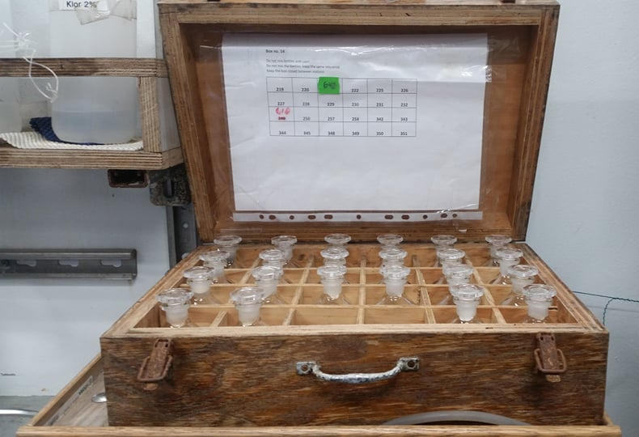
- 3 wood boxes with Pyrex precalibrated Flask: Each flask is numbered. The flask/stopper pairs must be calibrated by weighing each when empty and filled with distilled water (DIW) of a known temperature and then applying a buoyancy correction (DOE, 1994). A balance with a capacity of 300 g and a precision of 0.001 g is required. With care the volume of each flask can be known to ±0.003 ml.
Figure 2: Wood box with precalibrated Pyrex flasks, Picture: Claire Mourgues
- 2 pcs Micropipette and tips: 1ml – 10 ml and 100µl – 1 000 µl
- 2 pcs. Autopipettes with 25 ml syringe incl. user manual
- Several magnets for the Magnetic stirrer w / heating plate (between the fluorometer and the alkalinity titrator)
- 2 pcs. syringes 10 ml
- 1 pc. Syringe 50 ml headspace before acidification of the sample
- 2 pcs. plastic bottles w / screw cap 250ml for reagent A and B
- 3 pcs Reagent dispensers: for the Reagent A (MnCl₂), for the reagent B (NaI/NaOH) and for the Sulfuric Acid Solution. The dispenser containing the NaI/NaOH will require regular attention, because the plunger will begin to stick/bind to the glass. The NaI/NaOH dispenser should be thoroughly cleaned and disassembled for long-term storage between voyages because otherwise the plunger will become stuck.
- 5 pcs amber colored reagent bottles: It is recommended to use amber colored reagent bottles to prevent any light effect.
- Flexible plastic drawing tube or “noodle”: A length of thin-walled Tygon tubing long enough to reach from the petcock of the Niskin water sampler to the bottom of the oxygen sample flask. The diameter of the tubing must be large enough to allow a good rate of overflow of water as the flask is being filled. It is convenient to fit a short piece of highly flexible silicone tubing over one end of the drawing tube to make it easier to slip the tubing over the nipple of the petcock.
- Digital thermometer
- 3 pcs. beakers 100 mL
- 1 pc. squirt bottle for distilled water
- Metrohm Ti-Touch 916 (all manuals are on the USB storage plugged on the Ti-Touch Metrohm)
- 1 pc. Double Pt electrode (no storage condition)

REAGENTS AND PREPARATION

Manganous chloride (3 M): Reagent A
Slowly add 600 g of MnCl₂.4H₂O to a graduated flask containing 500-700 ml of DEST, stir until all the crystals have dissolved. The solution becomes cool upon preparation; allow it to reach ambient temperature then make the volume up to the 1 L mark with DEST. Filter the solution through a course glass fiber filter to remove any particulate material. If time or staffing is short, a magnetic stirrer can assist enormously. Please “BE SAFE” during make-up (behind a fume hood preferably) and please wear gloves and goggles.

Sodium iodide (4 M)/Sodium hydroxide (8 M): Reagent B
Dissolve 320 g of NaOH in a beaker containing roughly 500 ml of DEST. Allow the solution to cool. You have to place the graduated flask in a bucket fill with cold water. Then slowly add 600 g of NaI and allow the solution to cool again. Then add DEST to make the solution up to 1 L. Again, please “BE SAFE” whilst doing so (behind a fume hood preferably) and please wear gloves and goggles. It is particularly important to filter this solution because often there is a great deal of material that does not dissolve and some of this material has been found to be a reducing substance that contributes to the reagent blank.

Sulfuric acid (5 M):
Slowly add 280 ml of concentrated reagent grade H₂SO₄ to a graduated flask containing roughly 500 ml of DEST. Again, please “BE SAFE” whilst doing so (behind a fume hood preferably) and please wear gloves and goggles. You need to cool down the solution with cold water. Allow the solution to cool to ambient and then make up the volume to 1 L. A graduated beaker is sufficiently accurate for the preparation of this solution.

Thiosulfate (0,05N):
Given that the formula weight of Na₂S₂O₃.5H₂O is 248.17 g mole⁻¹. You would weigh out 25,0 g and make the volume up to 2.0 L in a volumetric flask. For some reason, it has been found that the thiosulfate solution is more stable and consistent if it is left to age (say 2 – 5 days). This leads to more consistent blanks and calibrations day to day, saving time and frustration. As such it may be advisable to make it up in quantities > 1 L.

Potassium iodate (0.00167 M or 0.0100 N):
Weigh out roughly 0.5 g of KIO3 and dry in an oven at 170°C for several hours. Weigh out 0.3567 g of the dried KIO₃, dissolve in DEST and make up to exactly 1 L in an “A –grade” volumetric flask. Measure the laboratory temperature and denote it as t_{P}. It cannot be overstated that the absolute accuracy of your oxygen analyses are dependent on the care you take with the preparation of KIO3 standard solution.

SECURITY AND SAFETY
Material safety data sheets (MSDS) for all chemicals are available digitally in IMR's chemical database and in the MSDS folder in the chemical storage. Please “BE SAFE” whilst sampling as the reagents, They are quite dangerous, so please wear goggles and if possible, gloves.

QUALITY CONTROL AND MEASUREMENT UNCERTAINTY
To calculate the precision of the oxygen measurements 10 replicates from the same Niskin bottle were analyzed. Average value = 6.042 St. deviation = 0.0054 were: coeff% = 0.0887. Generally, four Thiosulfate standards calibration are run, and the endpoints are averaged. The endpoints should be within ±0.3% of each other.

PROCEDURE SAMPLING
The collection of a seawater sample for oxygen analysis from the Niskin should be done as quickly as possible after the water sampler reaches the surface.

The first consideration must be given to sampling from the first triggered (deepest) Niskin due to the fact that the sample water has been in this bottle the longest, and undergone the greatest changes in Pressure and Temperature. Then consideration must be given to the warming of the water on deck in the sampler which can result in outgassing and loss of oxygen. Once water sampling from a Niskin begins a headspace develops inside the sampler and gas exchange between that headspace gas and the water in the sampler will begin immediately. For this reason a strict hierarchy has been established for the order in which water samples for gas analyses are drawn from the sampler. Those gases that are likely to experience the greatest contamination from the headspace, are drawn infrequently, or are very expensive or labor intensive to analyze are drawn first. The order that is observed on the CLIVAR/Repeat Hydrography cruises is CFCs, helium, noble gases (argon and xenon), O17, oxygen and pCO2. It is just as important that all the sampling for dissolved gases happen as quickly as possible once the water sampler arrives on deck.

Ensure that the Niskin water sampling bottles are properly closed and that there are no leakage from them. Check that the valve on top of the Niskin bottle is properly closed (check it before the CTD rack is launched). Water leaking from the tap when it is opened or from the bottom cap in the Niskin bottle indicates that the bottle has a leakage, a sample from a leaking bottle should be either discarded and resampled or given a remark in the Hydrographical form. The water from this sample depth might have been mixed with water from other depths or been exposed to air.

Please “BE SAFE” whilst sampling as the reagents you add are quite dangerous, so please wear goggles and if possible, gloves.

- You must fill the CTD Niskin log with the bottle number, the station number, the depth before sampling and the approximative Oxygen concentration

- Start tapping the bottle containing water from the deepest position.

- Confirm that the precalibrated Pyrex flask and stopper is a matched pair. If a flask or stopper is broken, do not replace one or the other.

- Connect the soft silicone tube, about 20 cm long to the nipple of the petcock on the water sampler, open the air vent on the top of the Niskin bottle and push in to start the flow of water. Dislodge any air bubbles within the tubing by squeezing or tapping with the output point to the sky.

- Rinse the sample bottle twice to remove any residual reagent from a previous analysis.

- Fill the sample flask by inserting the drawing tube all the way to the bottom of the flask. Fill the flask smoothly to minimize turbulence and aeration. Restricting the flow at the beginning by squeezing the drawing tube helps to minimize the bubbles that will otherwise form if the flow is too fast. This can also be assisted by commencing the “sample fill” with the bottle starting on roughly a 45o angle and as the fill progresses, move the flask to the upright position. Pay attention to how long the flask takes to fill. You should allow the flask to overflow for 2-3 times the time it took the flask to fill. This period of overflow is critical to obtaining a high quality sample. Your colleagues will complain about the waste of sample but it is critical to the precision of the oxygen analysis. The flask should be filled all the way to the top. Do not stopper the flask at this stage.

- while the flask is filling and overflowing insert the thermistor of a digital temperature meter into the flask and take a reading. .

- Add the pickling reagents: add 1 ml of the Reagent A (MnCl₂) and then 1 ml of the Reagent B (NaI/NaOH) with the dispenser under the water surface. 2 ml of sample equal to the volume of the two reagents will be lost as the stopper is inserted. This will be taken into account in the calculations.
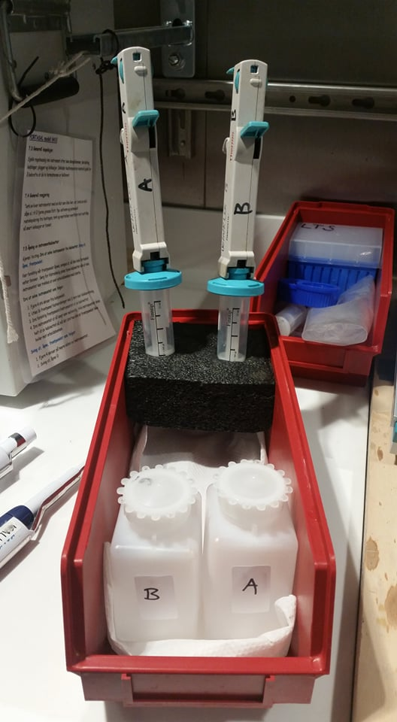

This step sounds simple but is a frequent source of error in the analysis. They may discharge a small quantity of air (as bubbles) so it can be appropriate to discharge a small amount to waste and draw up to refill the dispenser. Immerse the dispensing tip fully and dispense the reagent slowly and not too forcefully. The objective is to get the reagent to the bottom of the flask without too much mixing.

The reagent A and B are transferred in to two 250 ml plastic bottles labeled A and B in the red rack. The reactants are then filled into two Automatic dispensers with replaceable syringes. The syringes have a volume of 25 ml and the dispenser must be adjusted to give 1ml of reactant, the number on top of the pipette need to be 2. The automatic pipettes are labeled A and B and adjusted to the correct volume (1.0 mL) (according to the user manual user manual and the size of the syringe). Make sure not to mix the syringes to avoid contamination. It is important that the syringe does not contain air and does not drip. If so, replace the syringe. Remember to wipe the tip before the syringe is refilled to avoid contamination of the reactants (Winkler A and B)

- Add the stopper and shake.

- Stopper the flask being careful not to trap any air under the stopper.
Figure 3: Materiel to dispense reagent A and B during the sampling, Picture: Claire Mourgues
- Shake the flask vigorously for several seconds to thoroughly mix the reagents with the sample, hold well the stopper. If the sample and reagents are not be mix properly, you can obtain erratic and false results.

- Keep samples flask in the wood box and put the box in the grey cupboard next to the titrator. The wood box needs to be in the same room than the titrator (the sample will be at the same temperature than the thiosulfate). After 1 ½-2 hours you can analyze your samples. A second shaking of the flasks is recommended after approximately 30 minutes to ensure that all the oxygen in the flask has fully reacted with the reagents

The I₂ formed are sensitive to the light! So, you need to be very careful with your sample: Keep your sample, reagent blank and standardization thiosulfate in darkness.

You can immerge the bottles in water. This creates a seal and prevents air from entering the flask. This step is especially important for 2 prime reasons; the first being dry environments such as well air-conditioned ships, and the second being that warmer samples will still be contracting as they cool to ambient. If you fail to do this, bubbles will form in the flask during the wait before they are analyzed and the oxygen concentration will be several µ moles higher than it should be, and this cannot be corrected for as it is not consistent. However, if the water seal is maintained, the flasks can be stored for many days without any noticeable change in concentration.

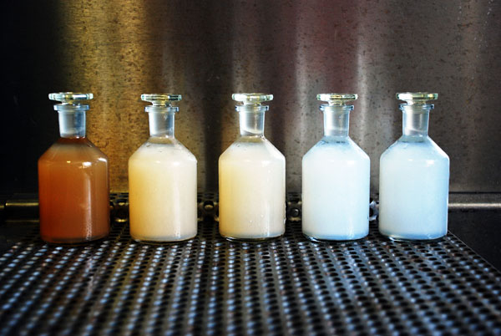
Figure 4: Oxygen sampling bottles after adding Winkler reagents A and B. High conc. to the left, low conc. to the right. Notice how the bottles and the caps are designed to avoid air bubbles. Picture: Lars-Johan Naustvoll

TITRATION PROCEDURES

Prepare the Metrohm Ti-Touch 916

- Turn on the Ti-Touch Unit, Press the power switch on the left-hand side of the black panel of the Ti-Touch unit
- Install the propeller stirrer, the electrode and the buret tip as follow
- Prepare the unit dosing with Thiosulfate 0.05N
- Opening the manual control (Press the key “hand” at the left of the red square)
- Select [Dosing] on the screen
- Select the function [Fill], [Prepare] or [Empty] Make sure to point your buret tip in a becher
- Go back to the main screen (press the house at the left of the screen)

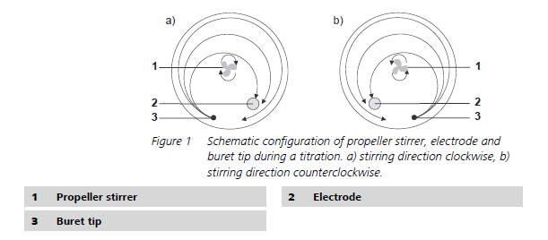
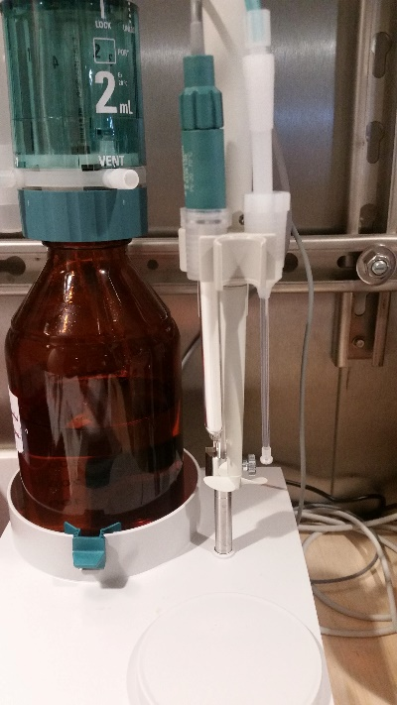

Figure 5: Schematic configuration of propeller stirrer, electrode and buret tip (left) and Picture of the dosing system (left, Picture: Claire Mourgues)

[Fill]: This function fill the system when you use the titrator for the first time or if you made a new Thiosulfate solution.
[Prepare]: The prepare function is used to rinse and fill the cylinder and tubing of the exchange or dosing unit air bubble-free. You should carry out this function before the first determination or once par day. It is very important to have no bubble before an analyze.
[Empty]: This function is used to empty the system at the end of a survey or when you make a new Thiosulfate solution. When you change your thiosulfate solution, this is very important to empty the system and to fill it with the new solution.

Reagent blank determination (Need to be done before each sequence)

As always, even during analyses, please “BE SAFE” and wear goggles and if possible, gloves.

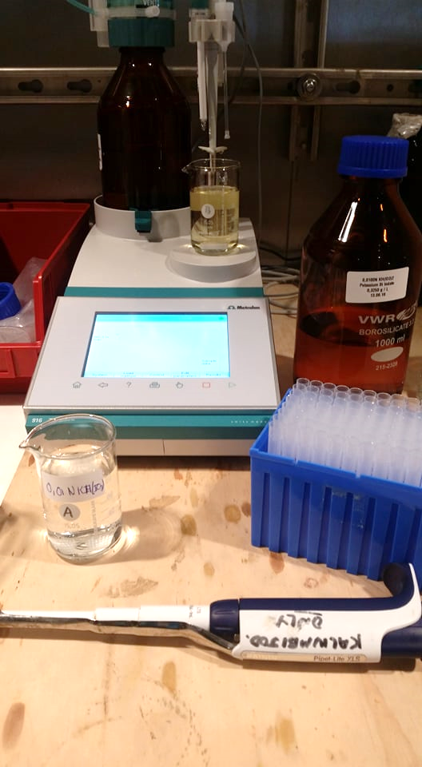
- Fill a becher with 80 ml of DEST water and add a stir bar
- Add 1 ml of KIO₃ solution using Micropipette (100 to 1000 µl) and mix well with the magnetic stirrer. Use a becher labelled for KIO₃, if you pipette in the bottle you can contaminate the reference solution and in fact you can determinate a wrong thiosulfate calibration.
- Add 1 ml of H₂SO₄ solution with the dispenser (figure 7, left) and mix with the magnetic stirrer (figure 7, right). If you use the dispenser for the first time, you need to dispense one or two times in a waste 1L glass bottle labelled.
- Add 1 ml of NaI/NaOH (Reagent B) and mix.
- Add 1 ml of MnCl₂ (Reagent A) and mix.
- Load the blank determination method (on the main screen, select [Load method], [internal memory], and select [Winkler Titration BLANK] and [LOAD], you can check if you have downloaded the method on the main screen in the blue line on top of the screen)
- Immerge the electrode, the stirrer and the buret tip
- Run the automatic titration (press the green play bottom)
- Note the volume V1 (very important, you need to note the volume after each analyze, access to the datas can be complicate)
- Add 1 ml KIO₃ in the same becher with a Micropipette (100 to 1000 µl)
- Run the automatic titration for the second time (press the green play bottom)
Figure 6: Materiel for the reagent blank determination, picture: Claire Mourgues
- Note the volume V2
- Rinse with DEST water the electrode, the stirrer and the buret tip
- Empty the becher and rinse it with TAP water and after with DEST water

With automated titration systems, you overshoot your first and point. Them, you need to calculate your Reagent blank value with the formula:
2V1 – V2 – V3
with V1 the volume (mL) of the first Endpoint, V2 the volume (ml) of the volume of the second endpoint and V3 the final volume (mL) for the first endpoint (V1 + 0,02mL)

Reagent Blank Value (mL): 2V1 – V2 – (V1+0,02)

Generally, four blank determination are run, and the Reagent blank value are averaged. This value should be within ±0.3% of each other.
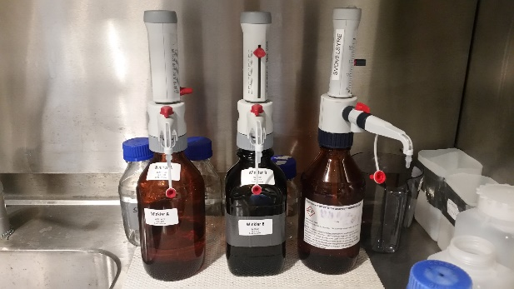
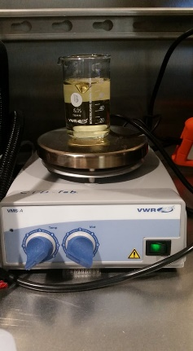
Figure 7: Dispenser for reagents A, B and for H₂SO₄ (left), Picture of the magnet stirrer to mix the sample between each adding (right), picture: Claire Mourgues

Standardization of thiosulfate solution (Need to be done every week)

As always, even during analyses, please “BE SAFE” and wear goggles and if possible, gloves.
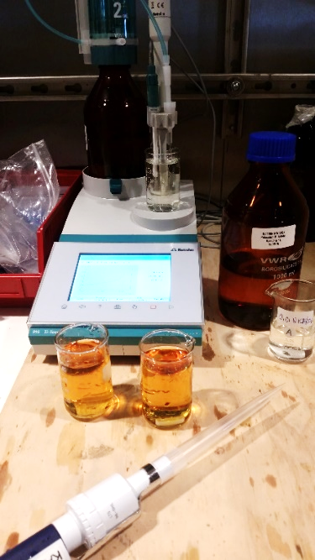
Figure 8: Materiel for the thiosulfate standardization, picture: Claire Mourgues
- Fill a becher with 80 ml of DEST water and add a stir bar
- Add 10 ml of KIO₃ solution using a Micropipette (1 to 10 ml) and mix well with the magnetic stirrer.
- Add 1 ml of H₂SO₄ solution and mix.
- Add 1 ml of NaI/NaOH (Reagent B) solution and mix.
- Add 1 ml of MnCl₂ (Reagent A) solution and mix.
- Load the Thiosulfate standardization method (on the main screen, select [Load method], [internal memory], and select [Winkler Titration STD] and [LOAD], you can check if you have downloaded the method on the main screen in the blue line on top of the screen)
- Immerge the electrode, the stirrer and the buret tip in the becher
- Run the automatic titration (press the green play bottom)
- Note the volume V_{thio} (You need to note the volume after each analyze, to access to the datas can be complicate)
- Rinse with DEST water the electrode, the stirrer and the buret tip
- Empty the becher and rinse it with TAP water and after with DEST water

Generally, four standards are run, and the endpoints are averaged. The endpoints should be within ±0.3% of each other.

Titration

The I₂ formed are sensitive to the light! So, you need to be very careful with your sample: Keep your sample, reagent blank and standardization thiosulfate in darkness.

As always, even during analyses, please “BE SAFE” and wear goggles and if possible, gloves.

- Note the bottle number, the bottle volume and the approximate Oxygen concentration in the Hydrographical form.
- After minimum 1 and ½ hours, you can analyze your sample
- Remove the stopper of sample flask and take out around 50 mL with the big plastic syringe. Don’t take up some of the blank precipitate.
- Add 1 ml of H₂SO₄, mix and allow the precipitate to dissolve. If all the precipitate does not dissolve, up to a second - 1 ml of H₂SO₄ can be added. At this step you cannot contaminate your sample with oxygen from the atmosphere
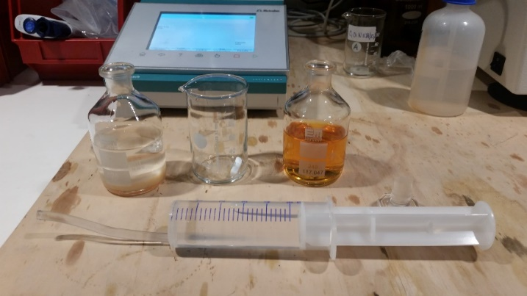
Figure 9: Picture of the sample transfert

- Transfer the sample in a becher and rinse well the sample flask with DEST water, this step is critical, you can lose some materiel (I₂), The sample is now ready for titration.
- Load the titration sample method: You need to be very careful. If you are not friendly with the Metrohm software, you need to select between the both methods. For the high concentration (2,5 to 5 ml.l), you will load the [sample Ox 2,5 to 5 ml.l] method and for the low concentration (0 and 2,5 ml.l), you need to load the method [sample Ox 0 to 2,5 ml.l]. For people comfortable with the software, you can play with the initial volume in the method [sample Ox initial volume (table 1)]. Never forget to save the method after changing the initial volume.
- Load the method corresponding to Oxygen concentration (on the main screen, select [Load method], [internal memory], and select [xxxxxxxx], you can check if you have downloaded the method on the main screen in the blue line on top of the screen)
- Immerge the electrode, the stirrer and the buret tip in the becher
- Run the automatic titration (press the green play bottom)
- Note the volume V_{sample} (You need to note the volume after each analyze, to access to the data can be complicate)
- Rinse with DEST water the electrode, the stirrer and the buret tip
- Empty the becher and rinse it with TAP water and after with DEST water

V_{initial} (ml) | CTD dissolved oxygen value (ml.l⁻¹)
2 | 5,5
1,4 | 4
1,0 | 3
0,7 | 2
0,3 | 1
0 | 0
Figure 10: Initial volume (ml) function of the dissolved oxygen CTD value (ml.l⁻¹)

MODIFY / ACCESS / PARAMETERS TO A METHOD
- On the main screen, press [Load method]
- Select [internal memory]
- Select [Show all]
- Select your method
- Load
- Back to the main menu, Press [Home] at the left bottom
- Select [Edit parameters]
- Select the command
- Select [Edit command]: Each method is organized with commands; a command can represent an End Point or the creation of a report. If you would like to determinate two EP for one sample, you need to create 2 commands.
- You can find in this document the parameters for the all methods created
MET Ipol Monotonic Titration U | Parameters | Winkler Titration Blank | Winkler Titration STD | Sample 0x 0 - 2,5 ml.l | Sample 0x 2,5 - 5 ml.l
Start conditions | Start volume | 0,13ml | 1,9 ml | 0,0 ml | 1,5 ml
 | Dosing rate | Max | Max | Max | Max
 | Pause | 30 s | 30 s | 30 s | 30 s
Sensor | mesure imput | 1 | 1 | 1 | 1
 | Sensor | Double Pt wire | Double Pt wire | Double Pt wire | Double Pt wire
 | Ipol | 1 yA | 1 yA | 1 yA | 1 yA
 | Electrode check | Off | off | off | Off
 | Temperature mesurement | automatic | automatic | automatic | automatic
Titration parameters | Titration data | User | user | user | User
 | User defined parameters
 | Volume increment | 0,008 ml | 0,008 ml | 0,008 ml | 0,008 ml
 | Dosing rate | Max | Max | Max | Max
 | Signal Drift | 20 mv/min | 20 mv/min | 20 mv/min | 20 mv/min
 | Min waiting Time | 0s | 0s | 0s | 0s
 | Max waiting Time | 26 | 26 | 26 | 26
 | Temperature | 25 | 25 | 25 | 25
Dosing device | Dosing device | 1 | 1 | 1 | 1
 | Titrant | Thiosulfate 0,05N | Thiosulfate 0,05N | Thiosulfate 0,05N | Thiosulfate 0,05N
Stop condition | Stop volume | Off | off | off | Off
 | Stop mesure value | Off | off | off | Off
 | Stop EP | 1 | 1 | 1 | 1
 | Volume after EP | 0,02 | 0,02 | 0,02 | 0,02
 | Stop time | Off | off | off | Off
 | filling rate | Max | max | max | Max
Stirrer | Stirrer | 1 | 1 | 1 | 1
 | Stirring rate | 5 | 5 | 5 | 5
 | Switch off automaticaly | Yes | yes | yes | Yes
Potentiometr. Evaluation | Ep criterion | 50 mV | 50 mV | 50 mV | 50 mV
 | EP recognition | All | all | all | All
 | set windows | Off | off | off | Off

CALCULATION OF OXYGEN CONTENT
Chemical reactions and stoichiometry:
Mn₂ + + 2OH⁻ -> Mn(OH)₂
2Mn(OH)² + ½O₂ + H₂O -> 2Mn(OH)₃
2Mn(OH)₃ + 2I- + 6H⁺ -> 2Mn2 + + I2 + 6H2O
I₂ + I⁻ <-> I₃
The amount of I₃ formed is chemically equivalent to the amount of oxygen, I₃ + 2S₂O₃²⁻> 3I⁻ + S₄O₆²⁻
This means that: 2S₂O₃²⁻ = I₂ = ½O₂ and that under ideal conditions 1 mol O₂ will be equivalent to 4 mol thiosulfate.
These factors are used further in the equation for determining the amount of oxygen:
1 mmol / L O₂ occupying 22.4 ml STP (standard temperature pressure). This means:
1ml O2 = 1 mmol / l O₂ (31.9988 mg = molmass O₂) /22.4 mL = 1.42857 mg O₂
1 mmol / l = 0.25 thiosulfate mmol / l O₂ = 7.9997 mg O₂ = 5.598 ml O₂
5598 ml is used further in the equation for determining the amount of oxygen
Determination of thio Sulphate normality (N_{thio}): N_{thio} = VIO₃ * NIO₃ /(V_{thio} -V_{blk})
where V = volume IO₃ iodate standard used in ml
NIO₃ = normality to iodate standard
V_{thio} = volume thiosulfate used for titration of standard in ml.
V_{blk} volume thio Sulphate used in the BLANK in ml.
Determination of oxygen in the sample:
O₂ (ml*L⁻¹) = (V_{thio} -V_{blk}) * N_{thio} * 1000 * 5598 / (V_{flaske}-V_{reag}) - (0.0017 / (V_{flaske}-V_{reag})) * 1000
where V_{thio} = volume thio Sulphate used for standard titration given in ml.
V_{blk} volume thiosulphate used in nooks in mL
N_{thio} = normality of thiosulphate
V_{flaske} = volume of the sample bottle in mL
V_{reag} = volume of added Winkler reagent A and B, usually 2 ml
0.0017 = amount of oxygen added with the reagents
5598 = mL O2 (STP) per. mol thiosulphate titrated
By simplifying the equation, we have that
O2 (ml * L-1) = (((V_{thio} - V_{blk}) * N_{thio} * 5598) - 1.7) / (V_{flaske}-V_{reag})
Today it becomes more and more common to express the oxygen concentration in the seawater weight basis (ĩmol / kg).
To convert ml-1 to ĩmol kg⁻¹, we need to know seawater specific gravity. This can be calculated from sigma theta calculated on basis of the potential temperature.
The equation becomes:
O₂ (ĩmol kg seawater⁻¹) = 44.660 * O₂ (ml * L⁻¹) / specific gravity of seawater
where seawater specific weight is equal to: 1+ (sigma-theta / 1000) and 44.66 is equal to (1000 / molar volume of oxygen gas at STP) (Weiss, 1981)

DATA STORAGE
All raw and processed date transferred to R: \ 434 Plankton \ Chemistry, Journal - Storage and transmission of electronic data by Chemistry Laboratory (Ines).

REFERENCES
Langdon, C. (2010). Determination of dissolved oxygen in seawater by winkler titration using the amperometric technique
Culberson, C. H., (1991). Dissolved oxygen. WOCE Operations
Grashoff, K. (1976). Methods of seawater analysis Winkler.

HYDROGRAPHIQUE LOG

Sign. in: Page nr: of

Vessel: RV Dr. Fritjof Nansen | Area: | Project code: | Survey nr:

Time sampling: | Time titration: | Thio cons:
Blank: | Metrohm Ti-Touch 916 | Secci depth:

Station | Date:  Time: | Niskin bottle | Depth:  (Press) | O₂ bottle | Vol | CTD Temp  (btl file) | CTD Oxygen (btl file) | Lab Temp | Volume Thio
Sign. Out:

